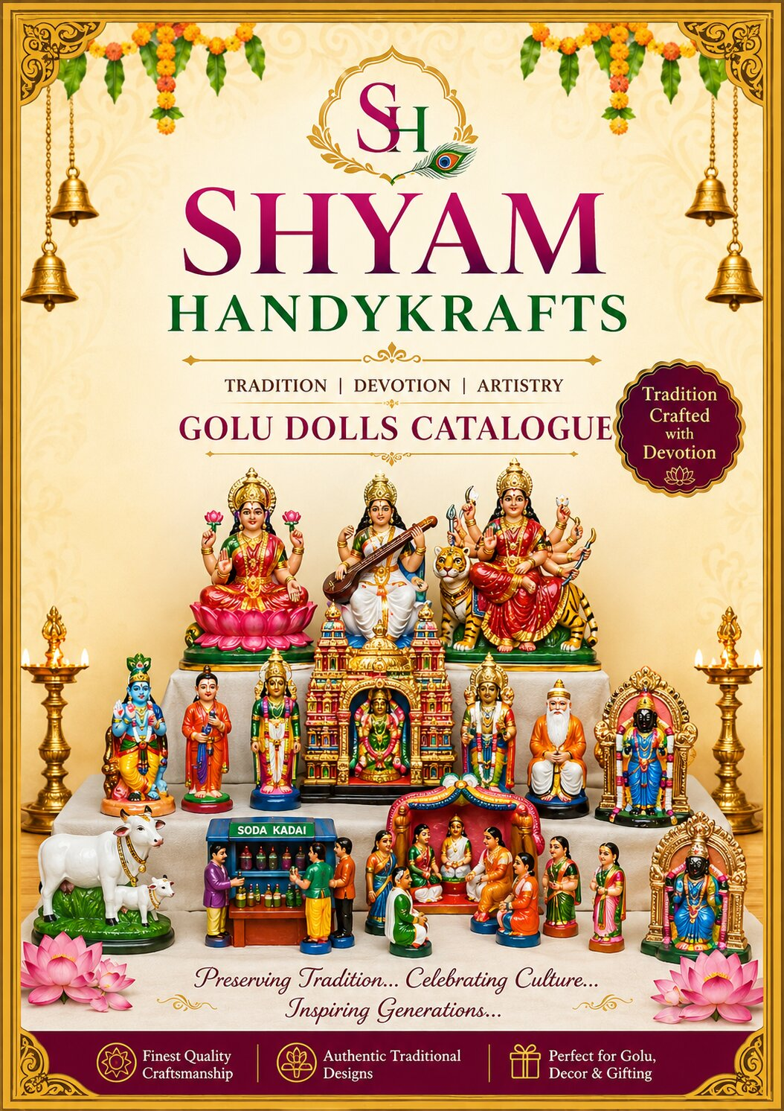

Serial No. | Name of Earthenware Golu Doll
1 | TRICHY UCHI PILLAYIAR SET
2 | KANCHI PERIYAVAR
3 | KALYANA RECEPTION SET
4 | TIRUPATHI SET
5 | PANCHAMUGAM ANUMAAN
6 | GIRIVALAM SET
7 | BOOVARAYAR PERUMAL
8 | LALITHAMBIGAI SET
9 | RAMAR HANUMAN
10 | RAMAR KUGAN
11 | RAMAR PATTABISEGAM SET
12 | VAARAGI AMMAN
13 | KRISHNA KUSELAR
14 | AISWARYA SIVAN SET
15 | PAZHANI MALAI KAVADI SET
16 | PERUMAL OONZAL SET
17 | MAHISHASOORA MARTHINI
18 | TIRUCHENDUR SOORASAMHARAM SET
19 | THULASI MAADAM AMMAN
20 | AYODHI RAMAR
21 | KAMATCHI BALA
22 | KARUMAARI AMMAN
23 | KARUDA SEVAI SET
24 | KUZHANDAI KAMATCHI
25 | NAVARASAM SET
26 | RANGANATHAR
27 | ALWARGAL SET
28 | MANU NEETHI SOZHAN SET
29 | ARTHA NAARISWARAR
30 | SAAPAADU SET
31 | SANJEEVI MALAI SET
32 | RAMAR PAALAM SET
33 | KAMATCHI
34 | VINAYAGAR BOZANAM SET
35 | TAATHA PAATTI BIG
36 | KOVARTHANA GIRI SET
37 | MAYILAI KABALEESWARAR SET
38 | KUBERAN SET
39 | MAAYA BAZAAR SET
40 | MADURAI VEERAN SET
41 | SURIYA RATHAM SET
42 | SIVALINGAM POOJAI SET
43 | PARTHA SARATHI SET
44 | NAALVAR SET
45 | VAARAGI AMMAN
46 | YAANAI SAVARI SET
47 | TAATHA PAATI SET
48 | ASHTABUJAM DURGAI
49 | MAAYA BAZAAR SET
50 | MADHURAA RADHA KRISHNAN SET
Serial No. | Name of Earthenware Golu Doll
51 | AMMAN KOIL SET
52 | AISWARYA SIVAN SET
53 | KANCHI DIVYADESAM SET
54 | TAATHA PAATI SET
55 | LAXMI NARAYANAR SET
56 | AARU PADAI VEEDU SET
57 | LAXMI KATAKSH VEEDU SET
58 | KUZHANTHAI THOTTIL SET
59 | BARADHA NAATTIYAM SET
60 | MUTTHANGI SEVAI PERUMAL
61 | KAL GARUDAN
62 | PONGAL SET
63 | THULAMBARAM SET
64 | KAMATCHI AMMAN
65 | AANDAAL PERUMAL SET
66 | KUZHAVAR SET
67 | ELENEER SET
68 | AGILAANDESWARI
69 | NAMMAALWAR KRISHNAN
70 | PAAVAI VILAKKU JODI SET
71 | MUM MOORTHIGAL SET
72 | THEEMITHI THIRUVIZHA SET
73 | PERIYALWAR ANDAL
74 | NITHIYA KALYANA PERUMAL
75 | KAILAAYAM SET
76 | KOLAPUR LAXMI
77 | NAMAKKAL ANJANEYAR
78 | DHASA AVATARAM SET
79 | THIYAGARAJAR KAMALAAMBIGAI SET
80 | SOLINGAR SET
81 | ANNA MALAIYAR SET
82 | ASTA LAXMI SET
83 | KARUDAN ANGANEYAR SET
84 | THANEER KUZHAI SET
85 | PANDURANGAN RAGUMAAYI SET
86 | KANCHI VARADAR THAYAAR SET
87 | ICE VANDI SET
88 | RAJA ALANGARA MURUGAR
89 | PERUMAL THAAYAR SET
90 | ELI-DANCE SET
91 | AYYAPPAN
92 | GAJA SAMHAARA MOORTHY
93 | KUMBAKARNAN AWAKENING SET
94 | BRAMMA URCHAVAM SET
95 | MAHOTSAVAM SET
96 | RAADHAI ALANGAARAM SET
97 | VIMAANAM
98 | VEDAN SET
99 | PAAVAI VILAKKU JODI SET
100 | RAMAR VIL UDAIPPU
Serial No. | Name of Earthenware Golu Doll
101 | POORI JAGANNAADAR SET
102 | AGRICULTURE SET
103 | SITHARGAL SET
104 | THATTHATREYAR SET
105 | LAXMI KUBERAN SET
106 | SAPTHA MAADHA SET
107 | KATHAKALI SET
108 | JANTUGAL SET
109 | KUZHANDAIGAL CRADLES SET
110 | GAJENDRA MOTCHAM SET
111 | ARTHA NAREESWARAR
112 | SRINIVAASAA KALYANAM SET
113 | KUZHANDAI BALA
114 | AMMAN
115 | TAATHA PAATI SET
116 | ARTHA NAAREESWARAR
117 | GOPI DANCE SET
118 | VINAYAGAR MUSIC SET
119 | LAXMI NARASIMMAR SET
120 | NAM PERUMAL AANDAL
121 | TRIMOORTHI
122 | RAMAR SITA SET
123 | ADI AANDA PRABU
124 | GAYATRI
125 | MAHISHASOORA MARTHINI
126 | RENUKA DEVI
127 | KAAMAATCHI VILAKKU POOJAI SET
128 | LAXMI DURGA SARASWATI SET
129 | ASTA LAXMI SET
130 | KAARTHIGAI PENGAL SET
131 | AMMAN
132 | AANDAVAR
133 | DHATCHINAMOORTHY
134 | MEENAKCHI GOPURAM
135 | VEENAI ANUMAN
136 | CHATURBUJ AMMAN
137 | KOODAL ALAGAR SET
138 | AMMAN KOIL SET
139 | KUBER AASIRWADAM SET
140 | NAMAKKAL ANJANEYAR
141 | KARUDAN ANGANEYAR SET
142 | ANNA MALAIYAAR SET
143 | AYYAPPAN
144 | NAALVAR SET
145 | RAMAR SET
146 | AMMAAL
147 | DEVI
148 | MAYIL MURUGAR
149 | ANNA MALAIYAAR SET
150 | LAXMI AYAGRIVAR
Serial No. | Name of Earthenware Golu Doll
151 | ARTHA NAAREESWARAR
152 | AMMAN
153 | PASUMAADU KANNUKUTTI
154 | AMMAN PERUMAL SET
155 | LAXMI DURGA SARASWATI SET
156 | RAMANUJAR
157 | ARTHA NAAREESWARAR
158 | AMMAN
159 | ARTHA NAAREESWARAR
160 | SODA KADAI SET
161 | AANDAL KRISHNAR SET
162 | KUBERAN SET
163 | WEDDING SET

 | EARTHENWARE GOLU DOLLS CATALOUGE  SHYAM HANDYKRAFTS | 100% Exports Free Shipping
SR No. | IMAGE | NAME AND DESCRIPTION | CODE No. | RATE IN USD
1 | 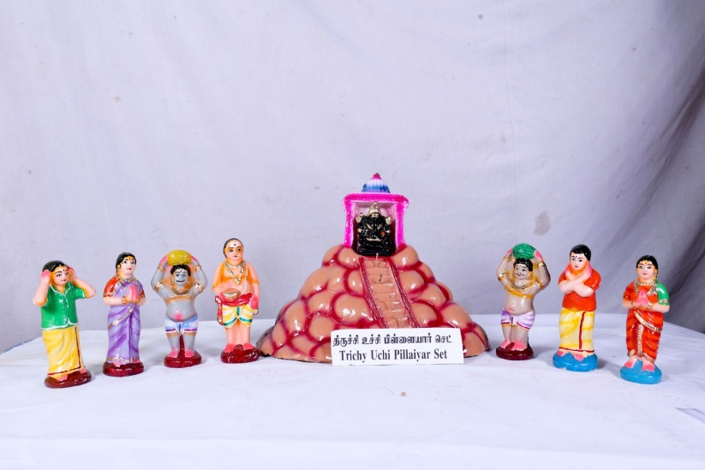 | TRICHY UCHI PILLAYIAR SET  Sacred Trichy Uchi Pillayar set, invoking Lord Ganesha’s divine grace from the holy heights of Rockfort. | BV1 | 150 USD
2 | 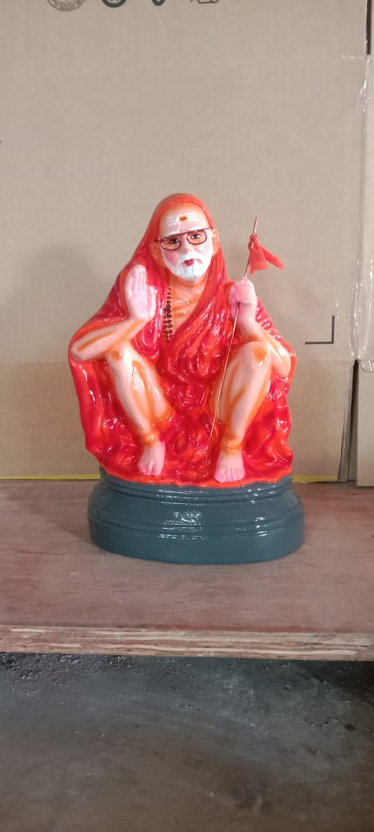 | KANCHI PERIYAVAR  Revered Kanchi Mahaperiyava, a beacon of dharma, simplicity, and spiritual enlightenment | BV2 | 75 USD
3 | 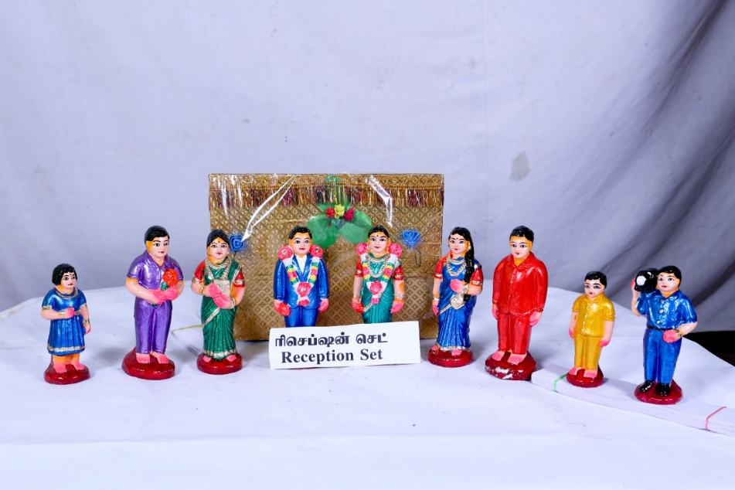 | KALYANA RECEPTION SET  Sacred wedding reception ensemble, symbolizing a blissful beginning filled with divine blessings and togetherness. | BV3 | 150  USD

 | EARTHENWARE GOLU DOLLS CATALOUGE SHYAM HANDYKRAFTS | 100% Exports Free Shipping
SR No. | IMAGE | NAME AND DESCRIPTION | CODE No. | RATE IN USD
4 | 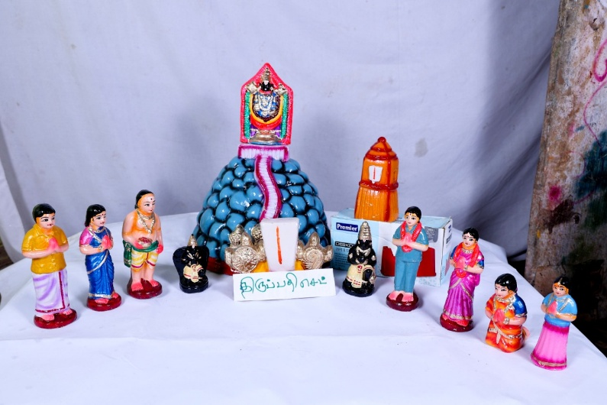 | TIRUPATHI SET  Sacred Tirupathi scene, embodying the divine darshan and grace of the Lord of Seven Hills | BV4 | 150 USD
5 | 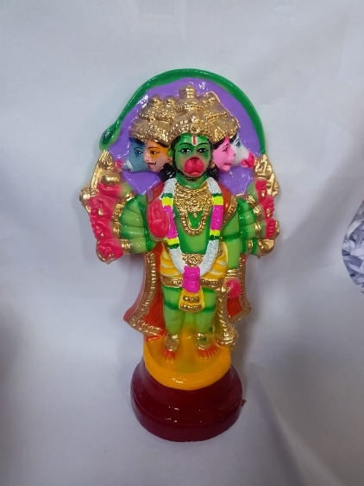 | Panchamugam Anumaan  Divine Panchamukhi Hanuman, radiating power, courage, and unwavering devotion across all directions | BV5 | 75 USD
6 | 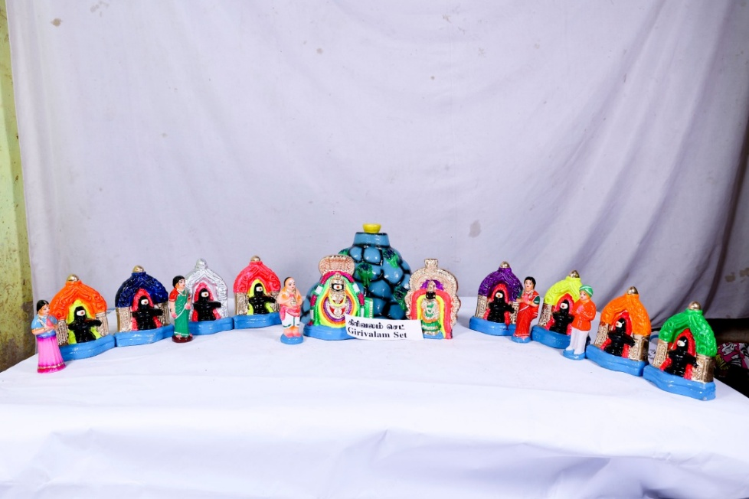 | GIRIVALAM SET  Holy Girivalam scene, capturing the divine experience of walking in devotion around the sacred Arunachala hill. | BV6 | 150 USD

 | EARTHENWARE GOLU DOLLS CATALOUGE SHYAM HANDYKRAFTS | 100% Exports Free Shipping
SR No. | IMAGE | NAME AND DESCRIPTION | CODE No. | RATE IN USD
7 | 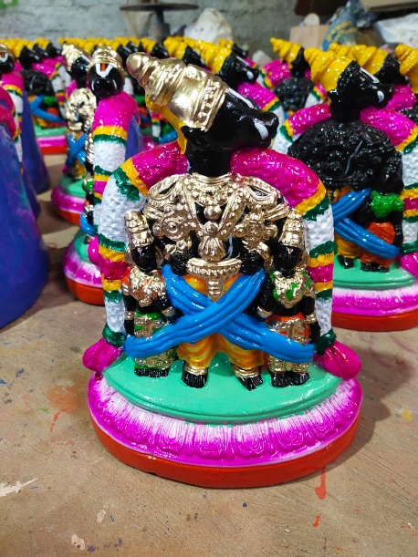 | BOOVARAYAR PERUMAL  Holy Boovarayar Perumal, embodying the supreme grace and benevolence of the Preserver of the universe | BV7 | 75 USD
8 | 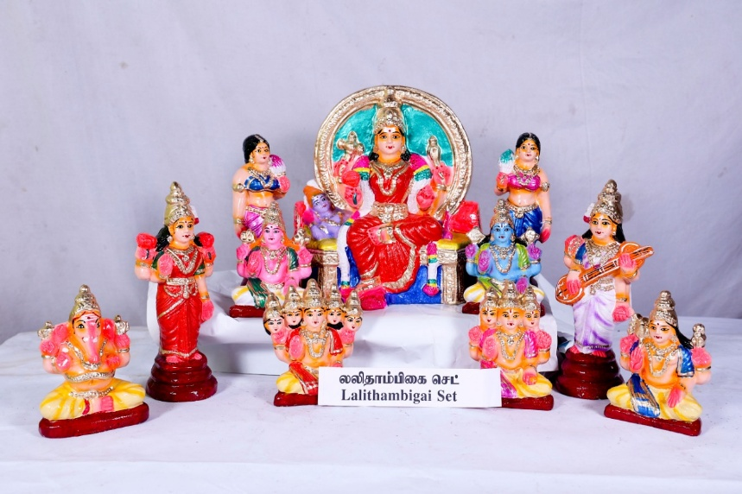 | LALITHAMBIGAI SET  Sacred Lalithambigai set, invoking the divine grace of Goddess Lalitha Tripurasundari, the embodiment of supreme Shakti. | BV8 | 250 USD
9 | 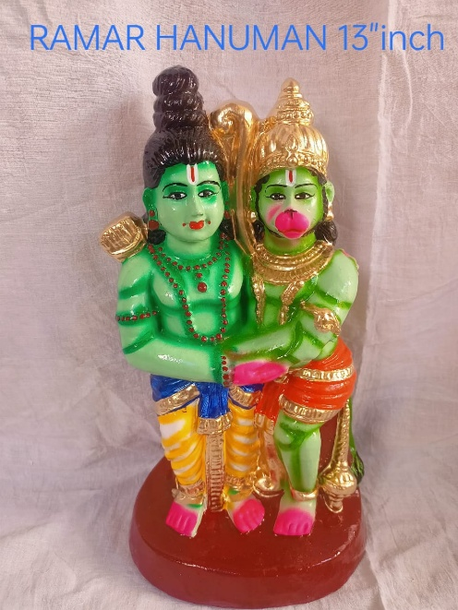 | RAMAR HANUMAN  Divine Ramar Hanuman set, symbolizing pure devotion, loyalty, and the grace of Lord Rama. | BV9 | 99 USD

 | EARTHENWARE GOLU DOLLS CATALOUGE SHYAM HANDYKRAFTS | 100% Exports Free Shipping
SR No. | IMAGE | NAME AND DESCRIPTION | CODE No. | RATE IN USD
10 | 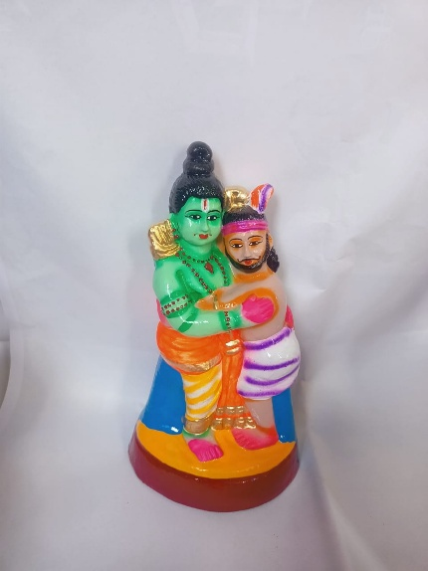 | RAMAR KUGAN  Sacred Ramar Kugan, portraying the pure devotion and heartfelt friendship of Kugan towards Lord Rama | BV10 | 99 USD
11 | 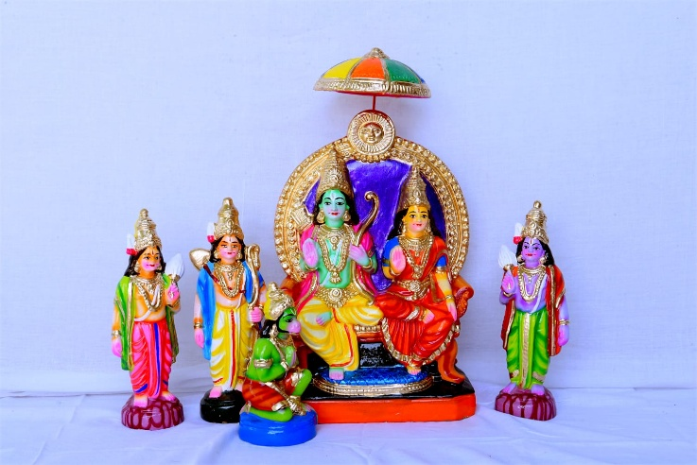 | RAMAR PATTABISEGAM SET  Sacred Ramar Pattabishegam set, depicting the divine coronation of Lord Rama, symbolizing dharma, victory, and righteous rule. | BV11 | 250 USD
12 | 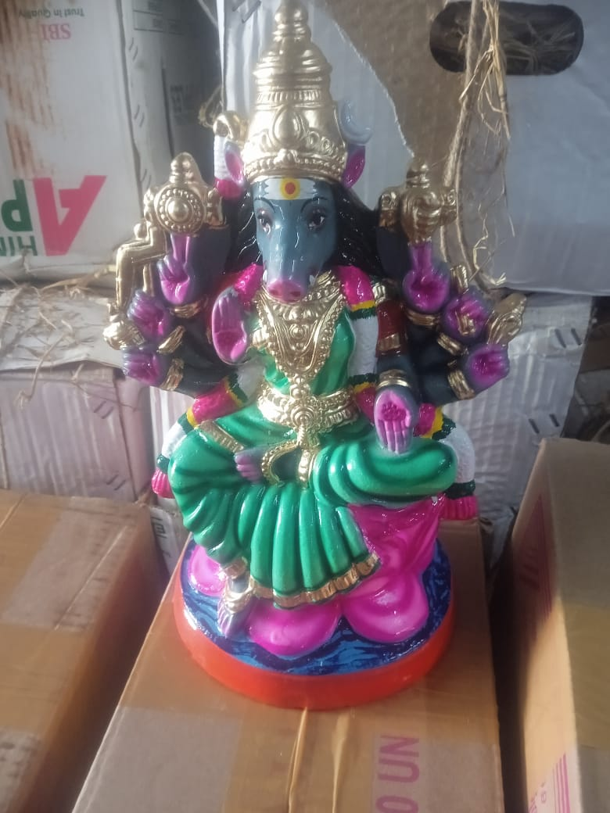 | VAARAGI AMMAN  Divine Vaaragi Amman, radiating fierce grace and shielding devotees with her supreme Shakti. | BV12 | 99 USD

 | EARTHENWARE GOLU DOLLS CATALOUGE SHYAM HANDYKRAFTS | 100% Exports Free Shipping
SR No. | IMAGE | NAME AND DESCRIPTION | CODE No. | RATE IN USD
13 | 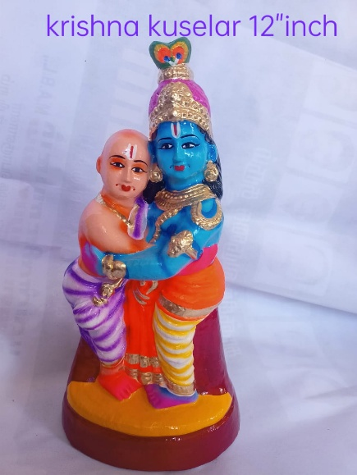 | KRISHNA KUSELAR  Sacred Krishna Kuselar, portraying the pure friendship and divine grace between Lord Krishna and His humble devotee Sudama | BV13 | 99 USD
14 | 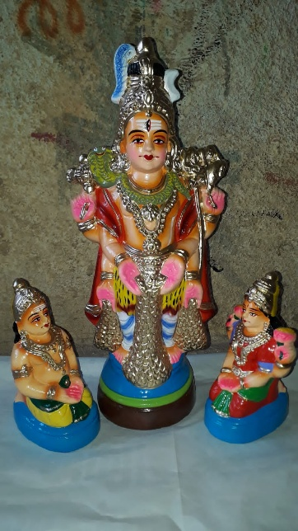 | AISWARYA SIVAN SET  Holy Aiswarya Sivan, embodying the powerful grace of Mahadeva, showering abundance and harmony in life | BV14 | 110 USD
15 | 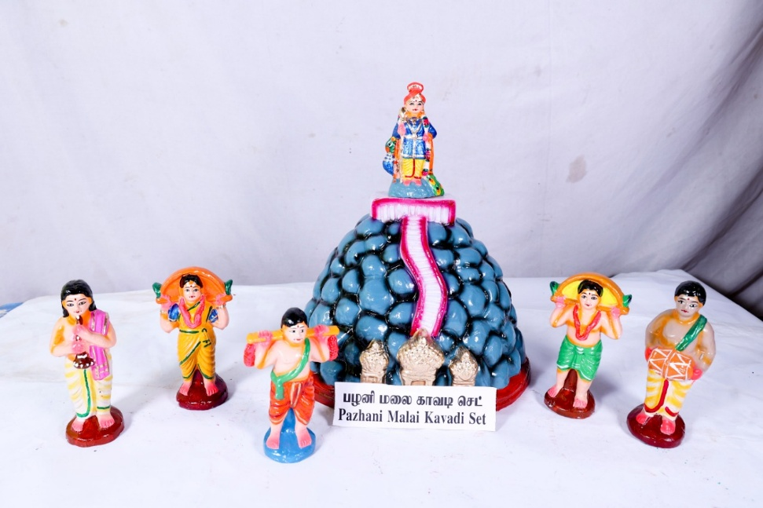 | PAZHANI MALAI KAVADI SET  Divine Pazhani Kavadi set, reflecting the spiritual journey of devotees seeking Lord Murugan’s blessings through sincere devotion.” | BV15 | 150 USD

 | EARTHENWARE GOLU DOLLS CATALOUGE SHYAM HANDYKRAFTS | 100% Exports Free Shipping
SR No. | IMAGE | NAME AND DESCRIPTION | CODE No. | RATE IN USD
16 | 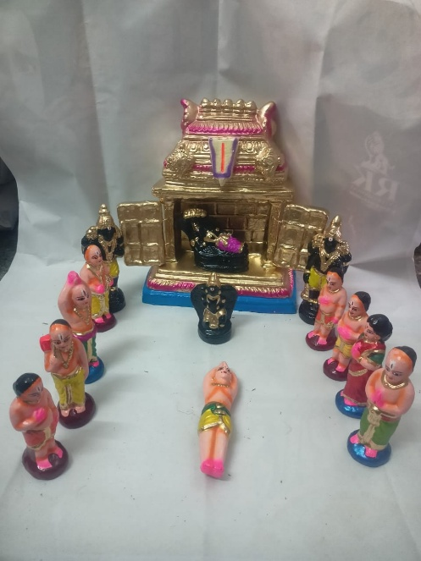 | PERUMAL OONZAL SET  Blessed Perumal Oonjal set, capturing the serene and loving form of Lord Vishnu in a moment of divine repose. | BV16 | 150 USD
17 | 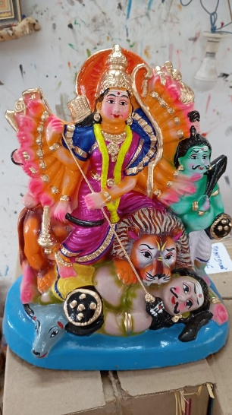 | MAHISHASOORA MARTHINI  Divine Mahishasura Mardhini, symbolizing the victory of righteousness as the Goddess vanquishes the demon Mahishasura.” | BV17 | 99 USD
18 | 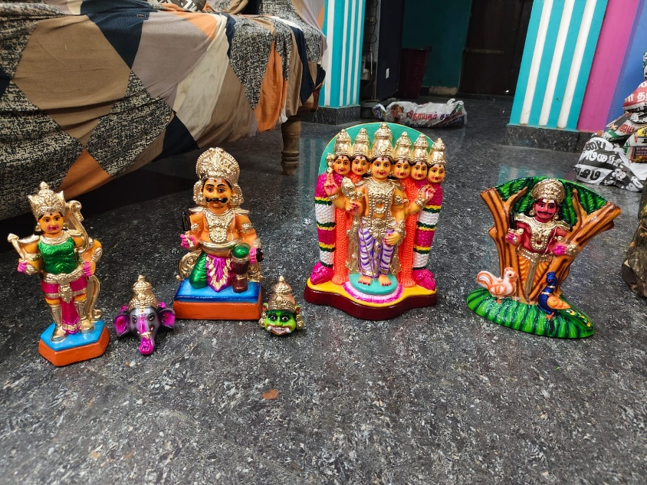 | TIRUCHENDUR SOORASAMHARAM SET  Sacred Tiruchendur Soorasamharam set, depicting Lord Murugan’s divine victory over Surapadman, symbolizing the triumph of good over evil.” | BV18 | 200 USD

 | EARTHENWARE GOLU DOLLS CATALOUGE SHYAM HANDYKRAFTS | 100% Exports Free Shipping
SR No. | IMAGE | NAME AND DESCRIPTION | CODE No. | RATE IN USD
19 | 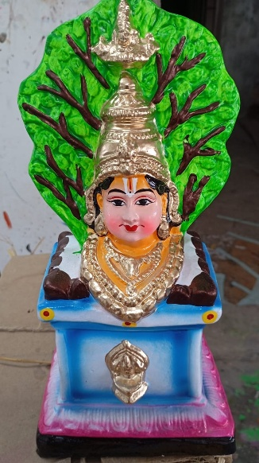 | THULASI MAADAM AMMAN  Blessed Thulasi Maadam Amman, representing the holy abode of Goddess Lakshmi, bringing peace and auspiciousness to every home. | BV19 | 99 USD
20 | 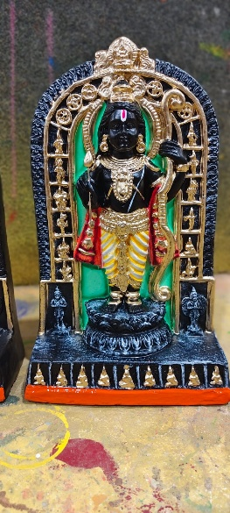 | AYODHI RAMAR  Divine Ayodhi Ramar, radiating the grace of Lord Rama, the ideal ruler and protector of truth. | BV20 | 75 USD
21 | 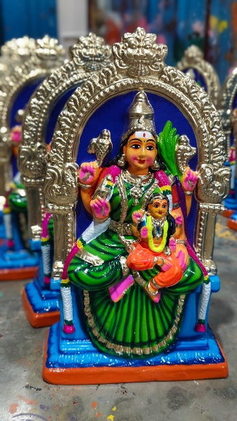 | KAMATCHI BALA  A spiritually uplifting Kamatchi Bala, invoking purity, prosperity, and the loving blessings of Goddess Kamakshi. | BV21 | 100 USD

 | EARTHENWARE GOLU DOLLS CATALOUGE SHYAM HANDYKRAFTS | 100% Exports Free Shipping
SR No. | IMAGE | NAME AND DESCRIPTION | CODE No. | RATE IN USD
22 | 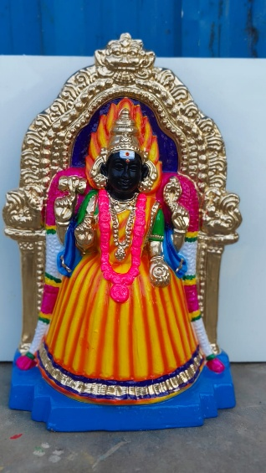 | KARUMAARI AMMAN  Blessed Karumaari Amman, symbolizing divine strength, healing, and the removal of hardships | BV22 | 120 USD
23 | 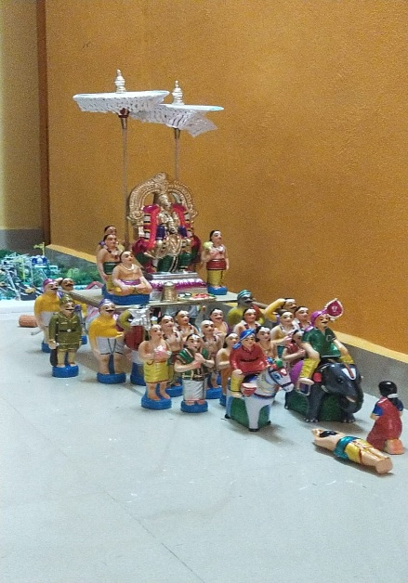 | KARUDA SEVAI SET  Divine Karuda Sevai, radiating the majestic presence of Perumal as He blesses devotees atop Garuda Vahana. | BV23 | 350 USD
24 | 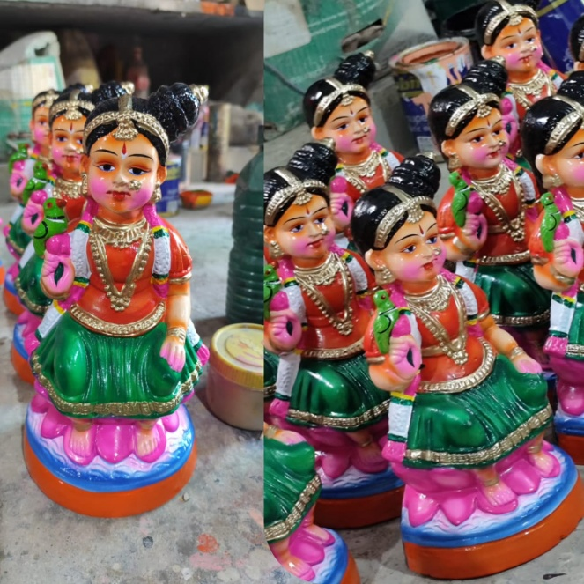 | KUZHANDAI KAMATCHI single piece  Sacred Kuzhandai Kamatchi, the divine child form of Goddess Kamakshi, radiating innocence, purity, and boundless grace. | BV24 | 90 USD

 | EARTHENWARE GOLU DOLLS CATALOUGE SHYAM HANDYKRAFTS | 100% Exports Free Shipping
SR No. | IMAGE | NAME AND DESCRIPTION | CODE No. | RATE IN USD
25 | 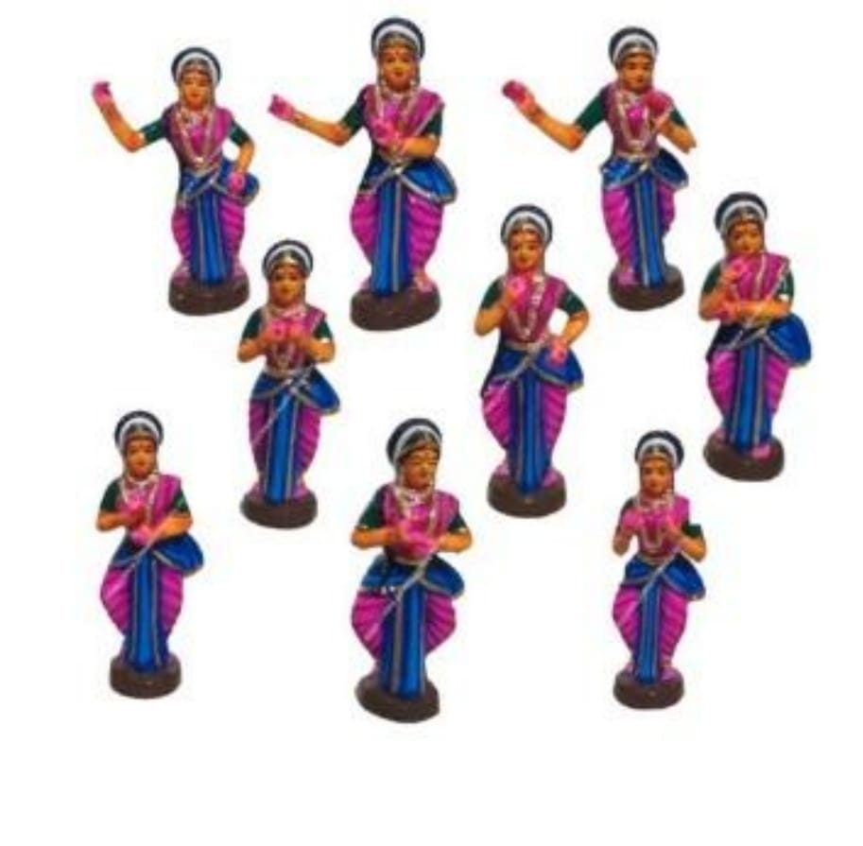 | NAVARASAM SET  Sacred Navarasam set, beautifully portraying the nine divine emotions that reflect the richness of life and spiritual expression | BV25 | 110 USD
26 | 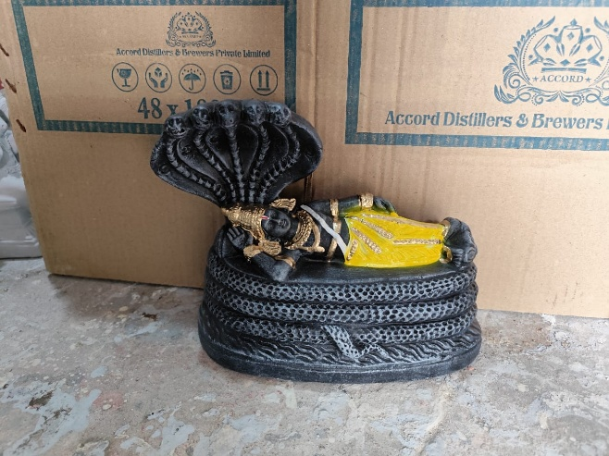 | RANGANATHAR  Divine Ranganathar, resting on Adisesha, symbolizing cosmic balance and the Lord’s serene presence | BV26 | 100 USD
27 | 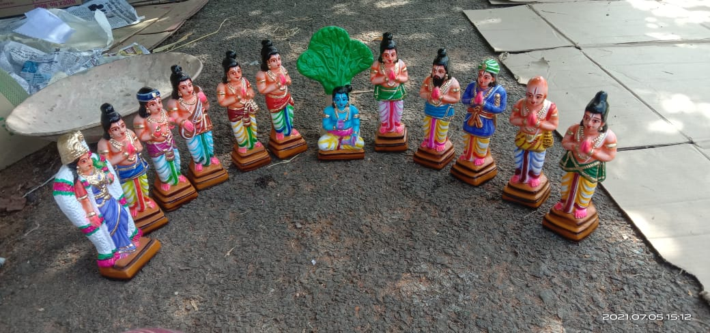 | ALWARGAL SET  Divine Alwargal ensemble, symbolizing the eternal bhakti and spiritual wisdom of the Vaishnavite saints. | BV27 | 150 USD

 | EARTHENWARE GOLU DOLLS CATALOUGE SHYAM HANDYKRAFTS | 100% Exports Free Shipping
SR No. | IMAGE | NAME AND DESCRIPTION | CODE No. | RATE IN USD
28 | 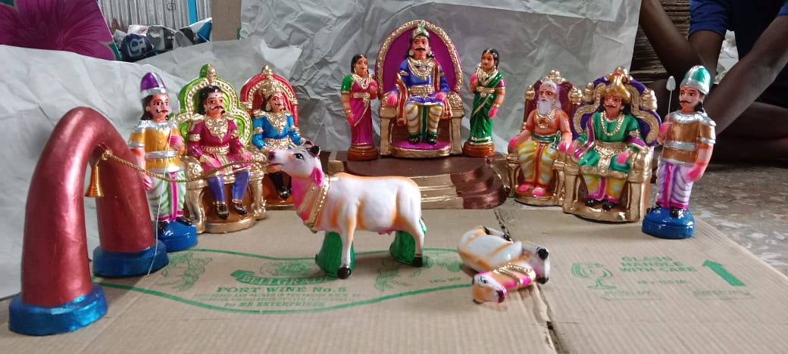 | MANU NEETHI SOZHAN SET  Divine Manu Neethi Sozhan, symbolizing the highest ideals of dharma, where justice prevails above all. | BV28 | 300 USD
29 | 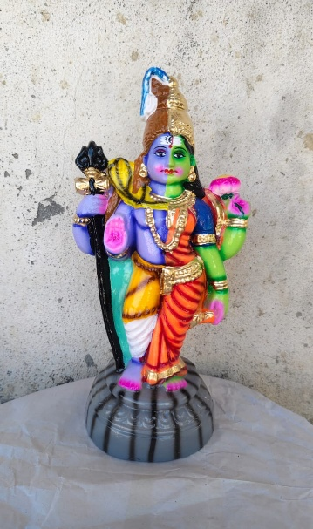 | ARTHA NAARISWARAR  Sacred Artha Naariswarar, the divine union of Lord Shiva and Goddess Parvati, symbolizing the perfect balance of masculine and feminine energies | BV29 | 99 USD
30 | 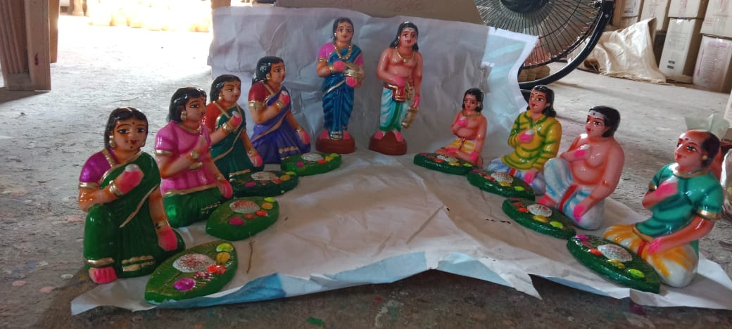 | SAAPAADU SET  “Blessed Saapaadu set, representing the holy act of Annadanam, the most sacred form of service | BV30 | 250 USD

 | EARTHENWARE GOLU DOLLS CATALOUGE SHYAM HANDYKRAFTS | 100% Exports Free Shipping
SR No. | IMAGE | NAME AND DESCRIPTION | CODE No. | RATE IN USD
31 | 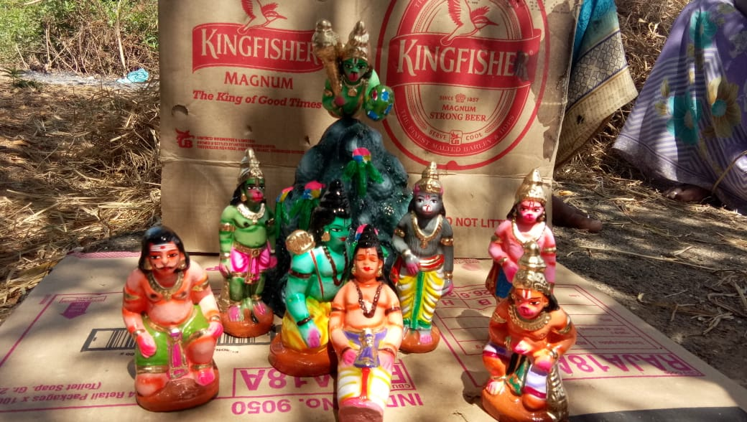 | SANJEEVI MALAI SET  Divine Sanjeevi Malai scene, portraying Hanuman’s unwavering dedication in bringing the sacred herb to save life. | BV31 | 250 USD
32 | 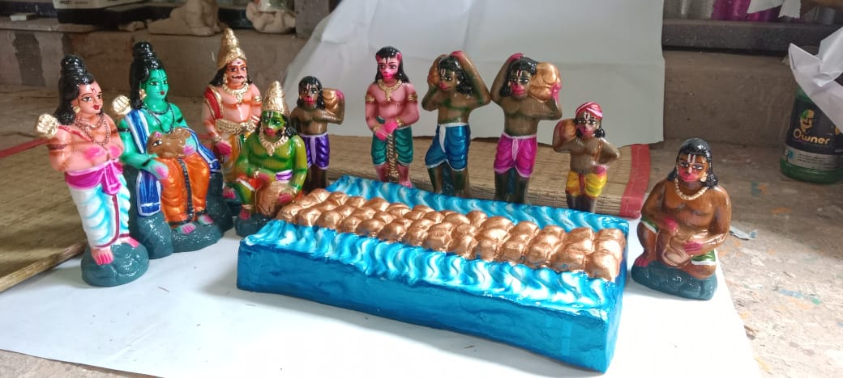 | RAMAR PAALAM SET  Divine Ramar Paalam scene, capturing the miraculous construction of the bridge to Lanka through unwavering devotion | BV32 | 250 USD
33 | 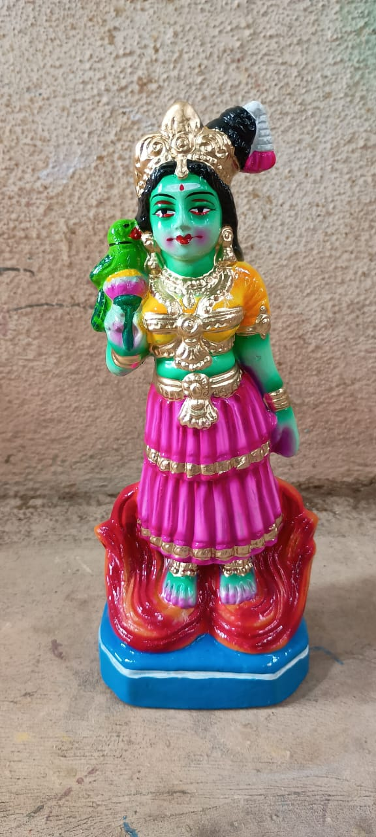 | KAMATCHI  Sacred Kamatchi Amman, the divine Mother of Kanchipuram, bestowing compassion, prosperity, and supreme Shakti | BV33 | 80 USD

 | EARTHENWARE GOLU DOLLS CATALOUGE  SHYAM HANDYKRAFTS | 100% Exports Free Shipping
SR No. | IMAGE | NAME AND DESCRIPTION | CODE No. | RATE IN USD
34 | 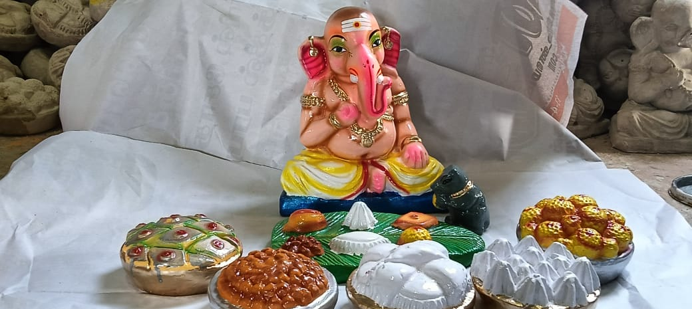 | VINAYAGAR BOZANAM SET  Holy Vinayagar Bozanam scene, embodying the joy of prasadam and the benevolent blessings of Lord Ganesha. | BV34 | 110 USD
35 | 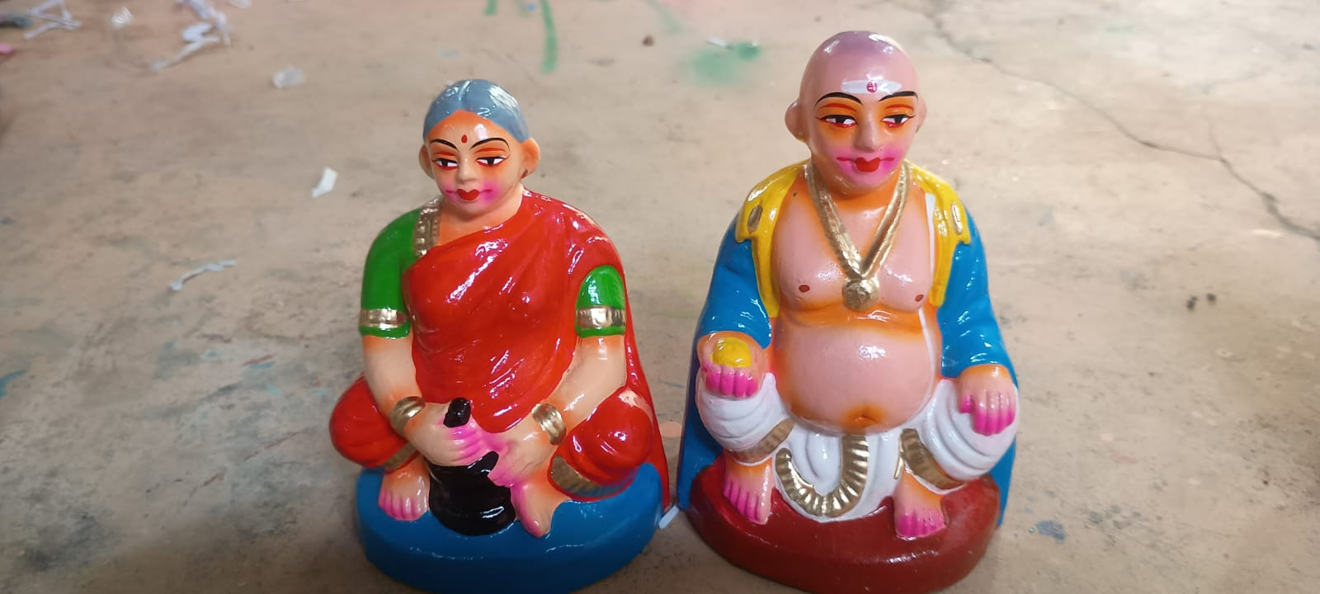 | TAATHA PAATTI BIG  “Divine Taatha Paatti, reflecting the grace and guidance of grandparents who nurture with compassion and values. | BV35 | 75 USD
36 | 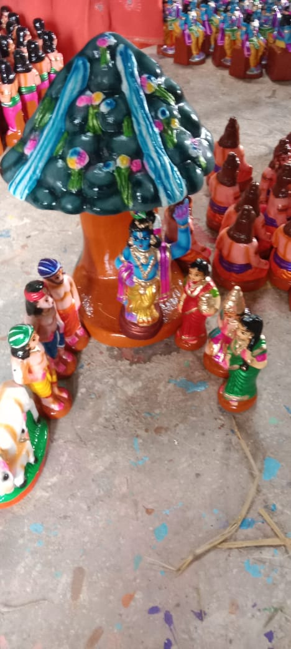 | KOVARTHANA GIRI SET  Divine Govardhana Giri scene, reflecting Lord Krishna’s boundless compassion in safeguarding all from harm | BV36 | 200 USD

 | EARTHENWARE GOLU DOLLS CATALOUGE SHYAM HANDYKRAFTS | 100% Exports  Free Shipping
SR No. | IMAGE | NAME AND DESCRIPTION | CODE No. | RATE IN USD
37 | 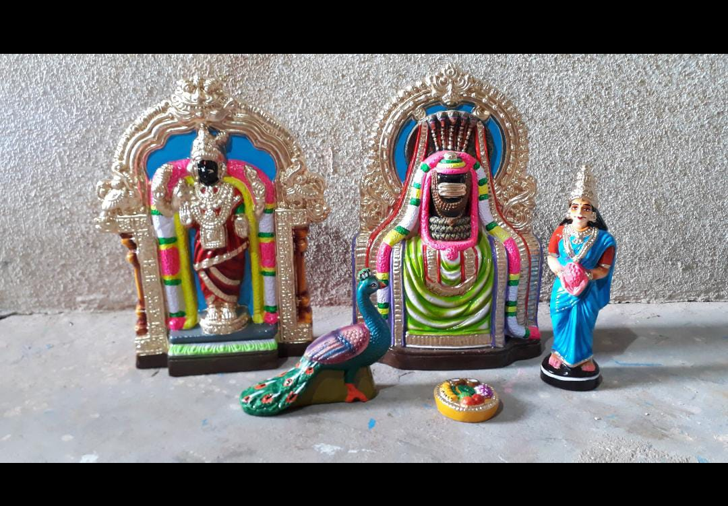 | MAYILAI KABALEESWARAR SET  A spiritually uplifting Mayilai Kapaleeswarar set, invoking devotion, protection, and the blessings of Lord Shiva | BV37 | 200 USD
38 | 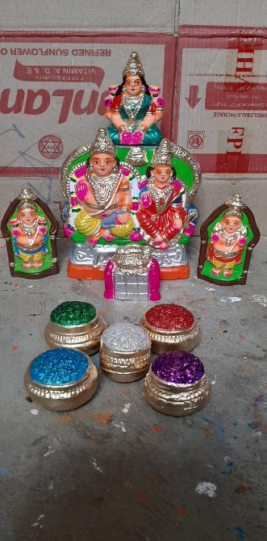 | KUBERAN SET  Divine Kuberan ensemble, symbolizing abundance, fortune, and the grace of the celestial treasurer. | BV38 | 110 USD
39 | 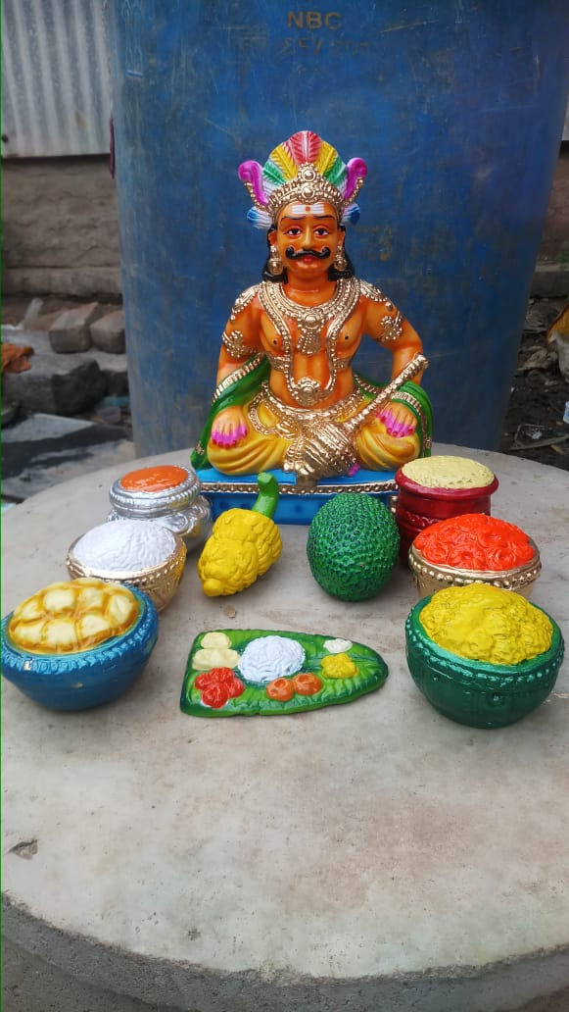 | MAAYA BAZAAR SET  Holy Maaya Bazaar, embodying the magical and divine play that reveals the Lord’s supreme power and compassion. | BV39 | 125 USD

 | EARTHENWARE GOLU DOLLS CATALOUGE SHYAM HANDYKRAFTS | 100% Exports Free Shipping
SR No. | IMAGE | NAME AND DESCRIPTION | CODE No. | RATE IN USD
40 | 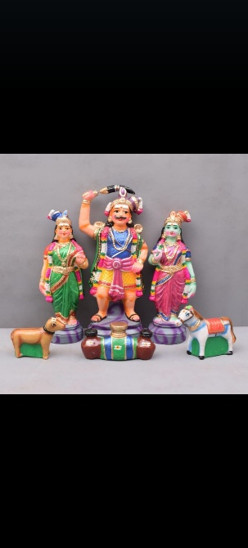 | MADURAI VEERAN SET  Sacred Madurai Veeran set, honoring the valiant guardian deity who protects with courage, loyalty, and divine strength | BV40 | 150 USD
41 | 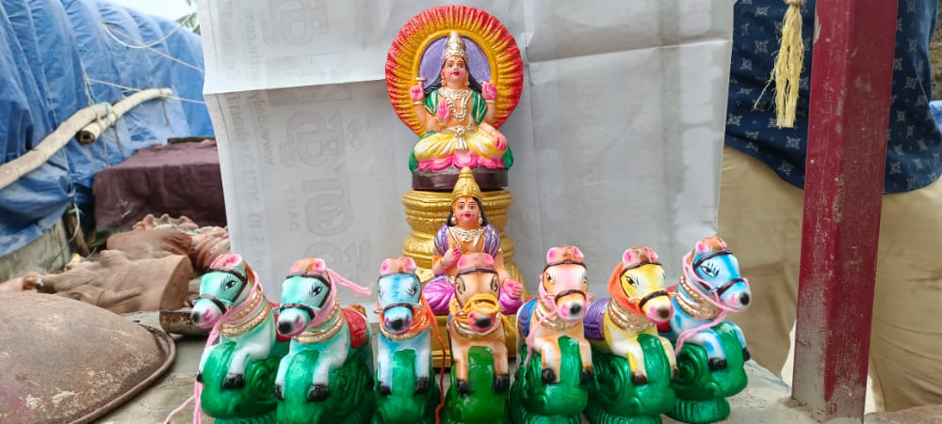 | SURIYA RATHAM SET  Sacred Suriya Ratham set, depicting the Sun God’s divine chariot, radiating light, energy, and life-giving blessings | BV41 | 110 USD
42 | 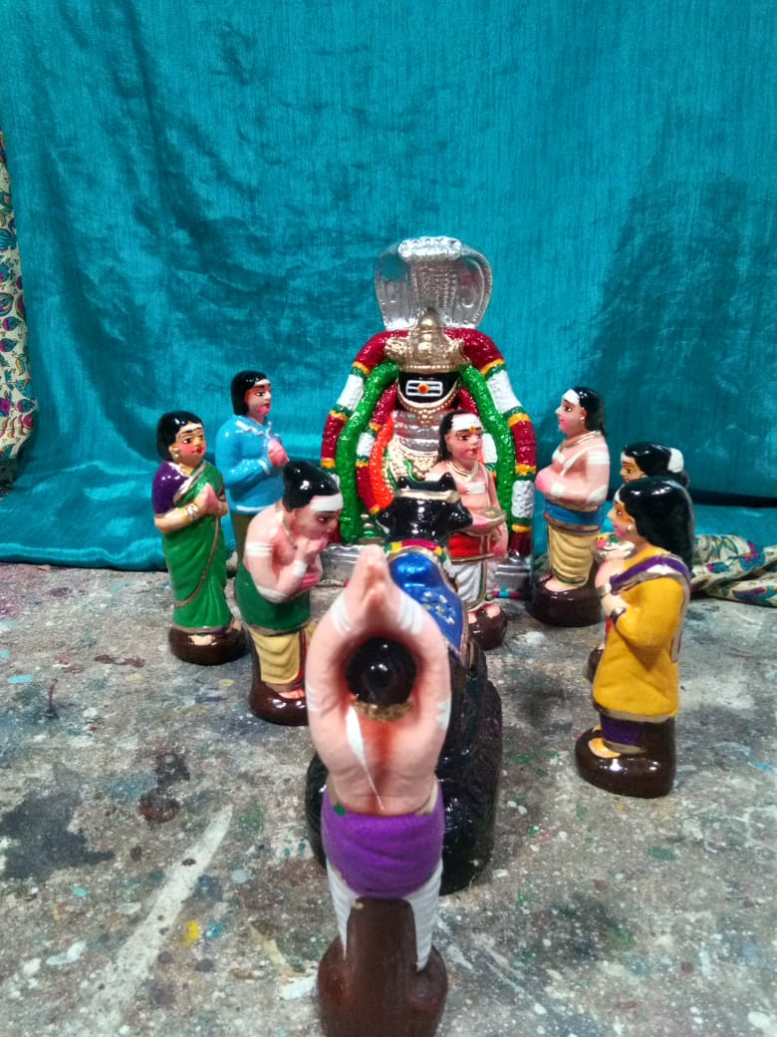 | SIVALINGAM POOJAI SET  Divine Sivalingam Pooja scene, symbolizing devotion, surrender, and the eternal presence of Lord Shiva | BV42 | Coming soon

 | EARTHENWARE GOLU DOLLS CATALOUGE SHYAM HANDYKRAFTS | 100% Exports Free Shipping
SR No. | IMAGE | NAME AND DESCRIPTION | CODE No. | RATE IN USD
43 | 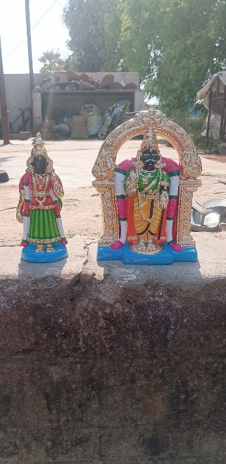 | PARTHA SARATHI SET  Divine Partha Sarathi, symbolizing the Lord’s wisdom and guidance in leading devotees through life’s battles. | BV43 | 200 USD
44 | 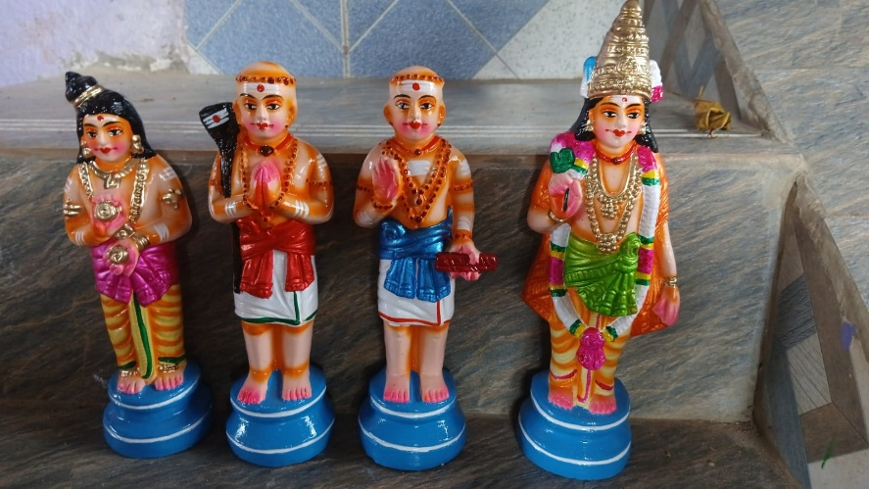 | NAALVAR SET  Sacred Naalvar set, honoring the four great Saivite saints whose devotion to Lord Shiva illuminated the path of bhakti | BV44 | 85 USD
45 | 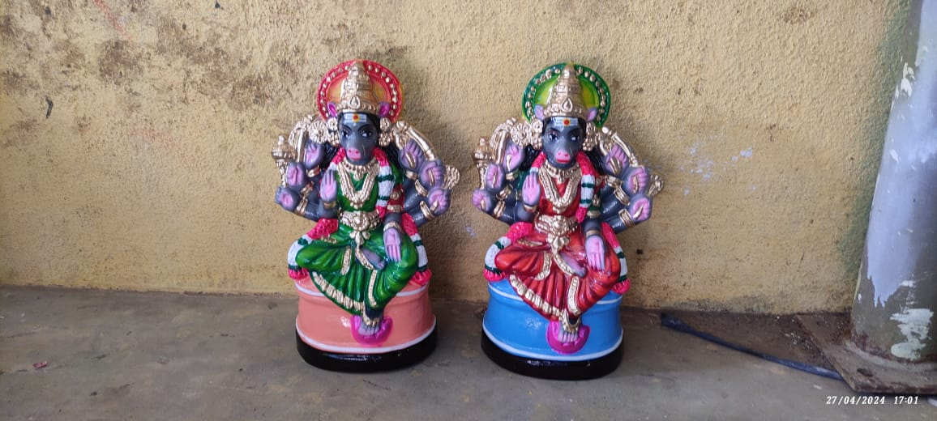 | VAARAGI AMMAN SINGLE PIECE  Blessed Vaaragi Amman, symbolizing divine power, wisdom, and the destruction of evil forces | BV45 | 75 USD

 | EARTHENWARE GOLU DOLLS CATALOUGE SHYAM HANDYKRAFTS | 100% Exports Free Shipping
SR No. | IMAGE | NAME AND DESCRIPTION | CODE No. | RATE IN USD
46 | 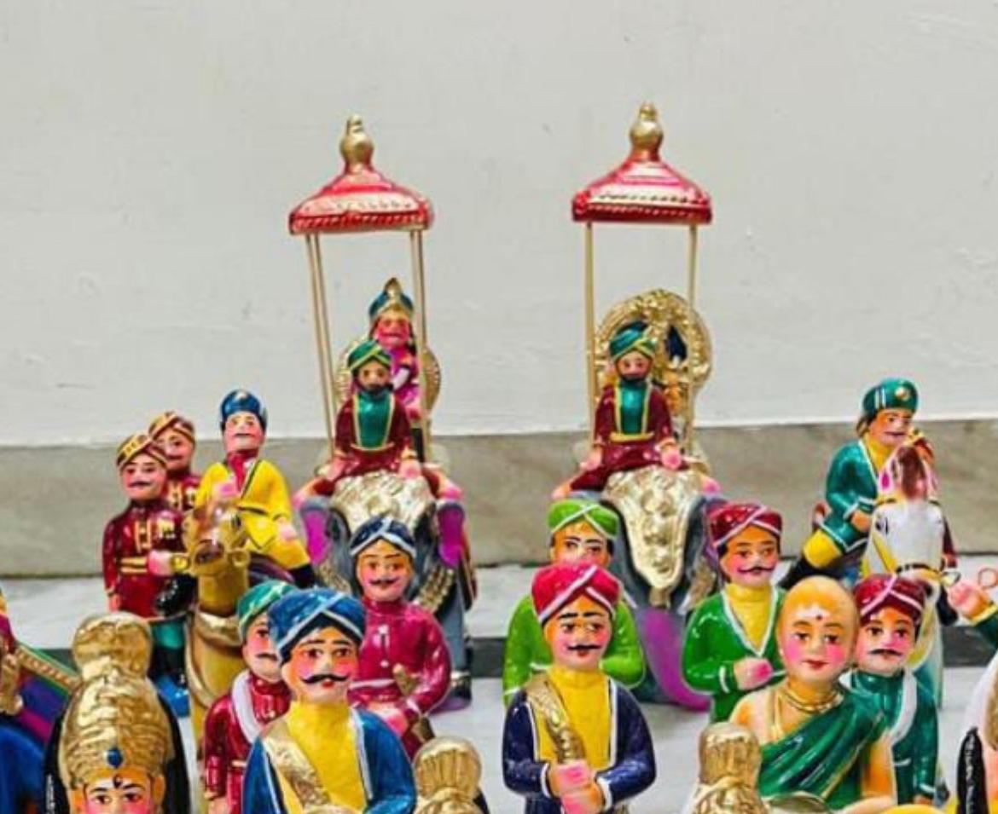 | YAANAI SAVARI SET  Sacred Yaanai Savari set, depicting the divine procession upon the elephant, symbolizing royal grace, strength, and auspicious blessings. | BV46 | Coming soon
47 | 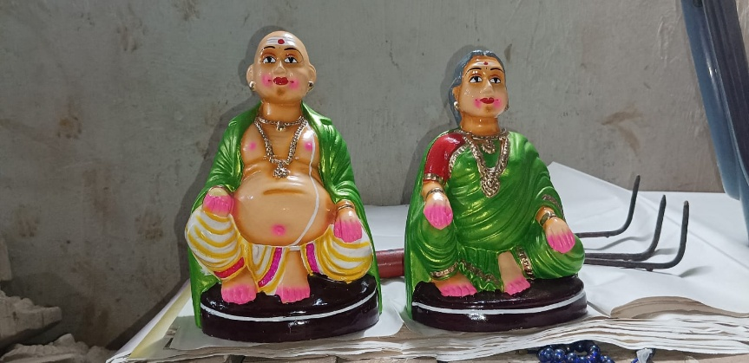 | TAATHA PAATI SET  Blessed Taatha Paati set, reflecting the timeless values, affection, and guidance passed through generations. | BV47 | 75 USD
48 | 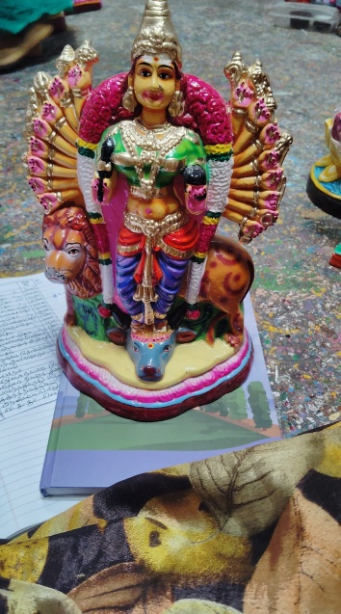 | ASHTABUJAM DURGAI  “Sacred Ashtabujam Durgai, the eight-armed Divine Mother, radiating supreme power, protection, and victory over evil. | BV48 | 99 USD

 | EARTHENWARE GOLU DOLLS CATALOUGE SHYAM HANDYKRAFTS | 100% Exports Free Shipping
SR No. | IMAGE | NAME AND DESCRIPTION | CODE No. | RATE IN USD
49 | 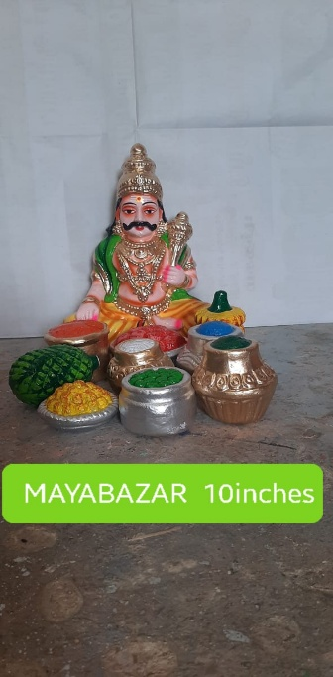 | MAAYA BAZAAR SET  Blessed Maaya Bazaar set, reflecting the enchanting leelas through which the Lord protects righteousness. | BV49 | 125 USD
50 | 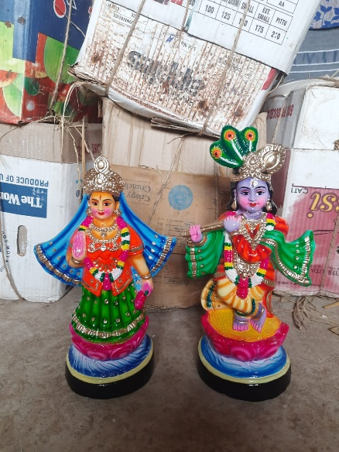 | MADHURAA RADHA KRISHNAN SET  Divine Madhuraa Radha Krishna, embodying the pure and enchanting bond of love between the Lord and His beloved. | BV50 | 125 USD
51 | 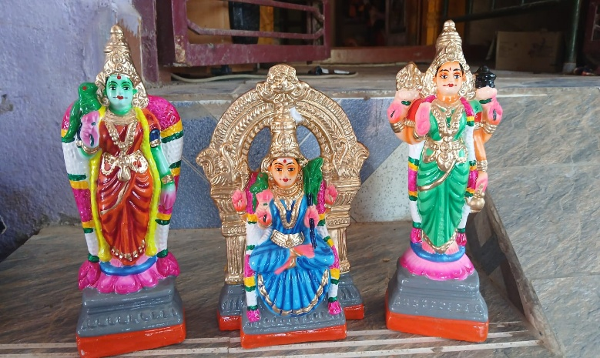 | AMMAN KOIL SET  Blessed Amman Koil set, reflecting the sacred atmosphere of temple worship filled with devotion and divine energy. | BV51 | Coming soon

 | EARTHENWARE GOLU DOLLS CATALOUGE SHYAM HANDYKRAFTS | 100% Exports Free Shipping
SR No. | IMAGE | NAME AND DESCRIPTION | CODE No. | RATE IN USD
52 | 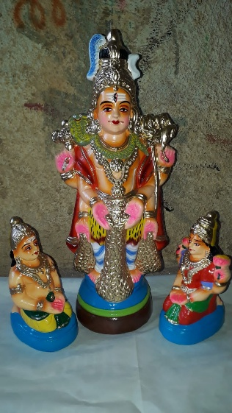 | AISWARYA SIVAN SET  Divine Aiswarya Sivan, radiating the grace of Mahadeva who bestows wealth, peace, and auspiciousness. | BV52 | 150 USD
53 | 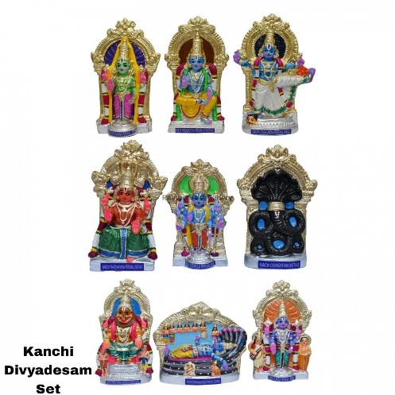 | KANCHI DIVYADESAM SET  Divine Kanchi Divyadesam ensemble, depicting the revered nine temples where Lord Perumal blesses devotees with salvation and peace. | BV53 | 400 USD
54 | 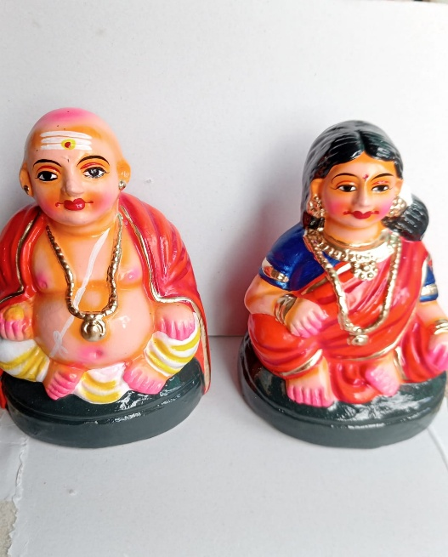 | TAATHA PAATI SET  A spiritually uplifting Taatha Paati set, invoking wisdom, love, and the cherished blessings of revered elders | BV54 | 75 USD

 | EARTHENWARE GOLU DOLLS CATALOUGE SHYAM HANDYKRAFTS | 100% Exports Free Shipping
SR No. | IMAGE | NAME AND DESCRIPTION | CODE No. | RATE IN USD
55 | 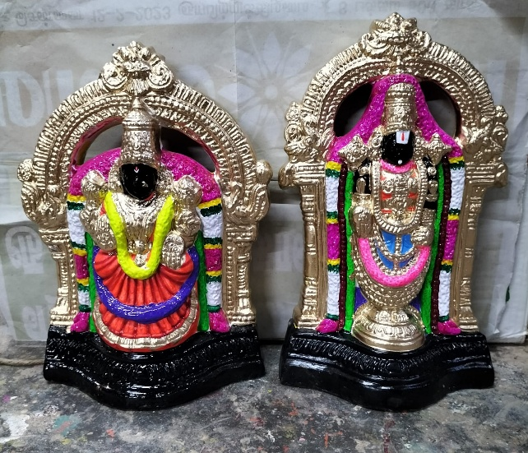 | LaxmiNarayanar set  Blessed Lakshmi Narayanar set, embodying the grace of Lord Narayana and the prosperity of Goddess Lakshmi.” | BV55 | 125 USD
56 | 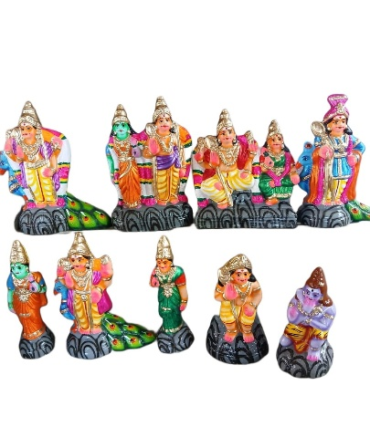 | AARU PADAI VEEDU SET  Sacred Aaru Padai Veedu set, representing the six holy abodes of Lord Murugan, radiating divine valor, wisdom, and grace | BV56 | Coming soon
57 | 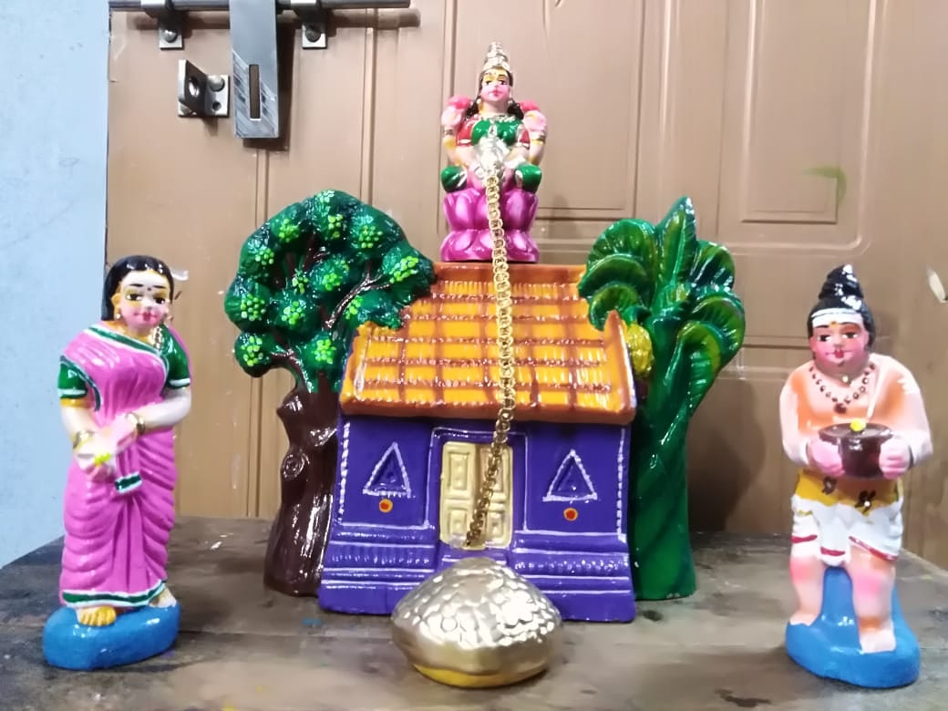 | Laxmi Kataksh Veedu set  Divine Lakshmi Kataksha Veedu, symbolizing the blessed household graced by the compassionate gaze of Goddess Lakshmi | BV57 | 200 USD

 | EARTHENWARE GOLU DOLLS CATALOUGE SHYAM HANDYKRAFTS | 100% Exports Free Shipping
SR No. | IMAGE | NAME AND DESCRIPTION | CODE No. | RATE IN USD
58 | 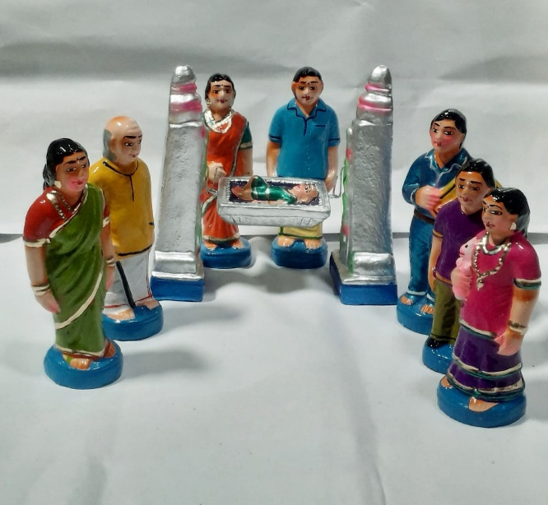 | KUZHANTHAI THOTTIL SET  Sacred Kuzhanthai Thottil set, depicting the divine child resting in the cradle, symbolizing innocence, blessings, and nurturing grace | BV58 | 200 USD
59 | 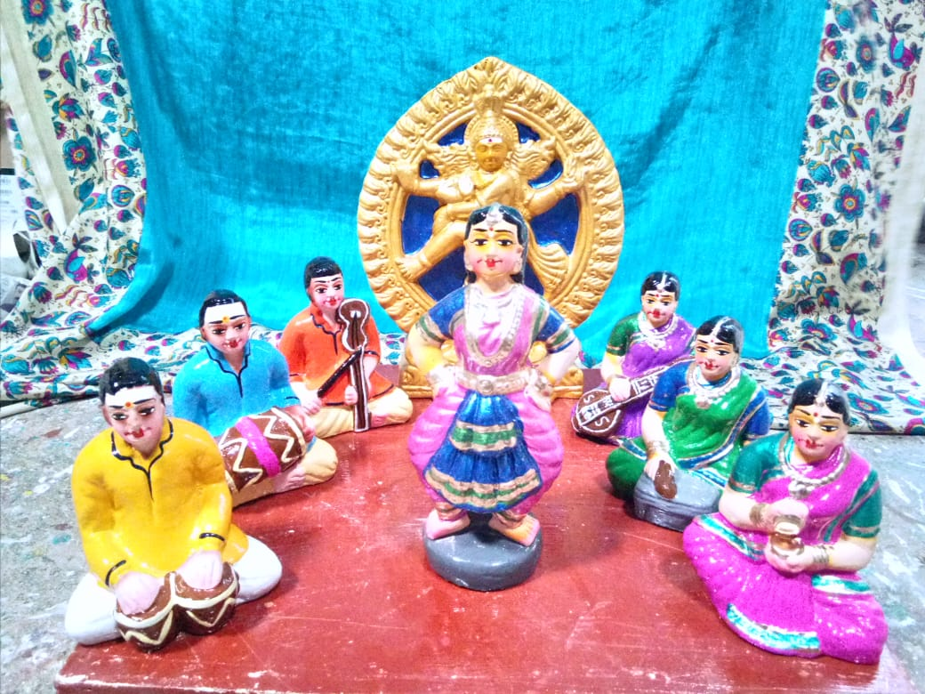 | BARADHA NAATTIYAM SET  Sacred Bharatha Nattiyam set, depicting the divine art of classical dance offered as a soulful expression of devotion | BV59 | 200 USD
60 | 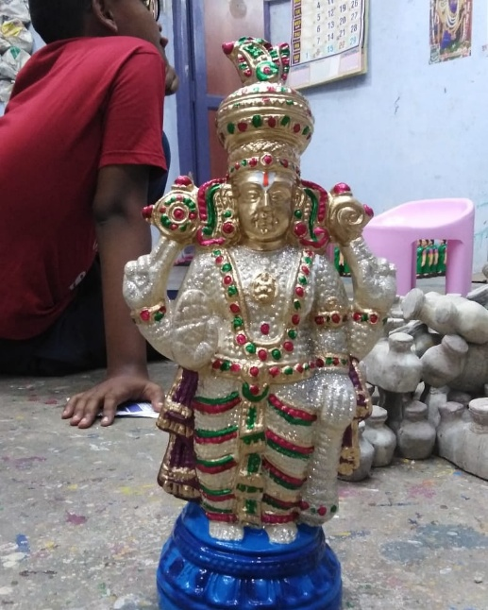 | MUTTHANGI SEVAI PERUMAL  Divine Mutthangi Sevai Perumal, symbolizing the Lord’s majestic alankaram, bestowing prosperity and spiritual bliss. | BV60 | 99 USD

 | EARTHENWARE GOLU DOLLS CATALOUGE SHYAM HANDYKRAFTS | 100% Exports Free Shipping
SR No. | IMAGE | NAME AND DESCRIPTION | CODE No. | RATE IN USD
61 | 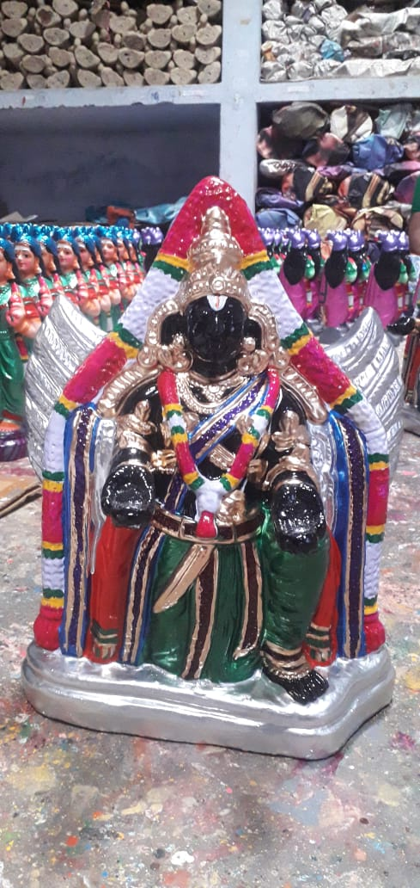 | KAL GARUDAN  Holy Kal Garudan, radiating protection, devotion, and the majestic grace of Garuda Vahana.” | BV61 | 110 USD
62 | 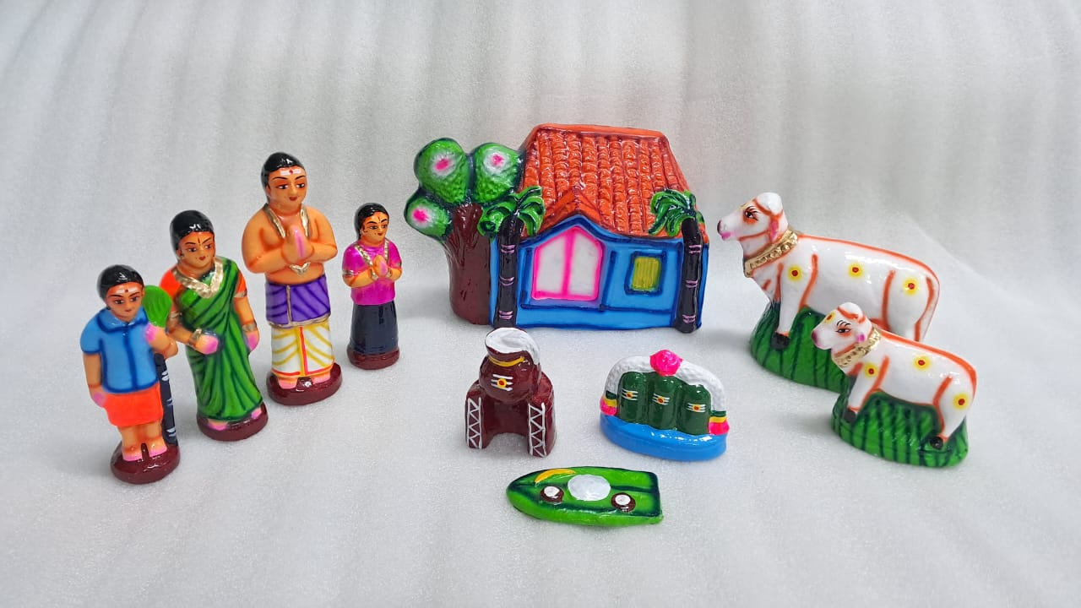 | PONGAL SET  Sacred Pongal set, celebrating the harvest festival with gratitude to the Sun God for abundance and prosperity | BV62 | 110 USD
63 | 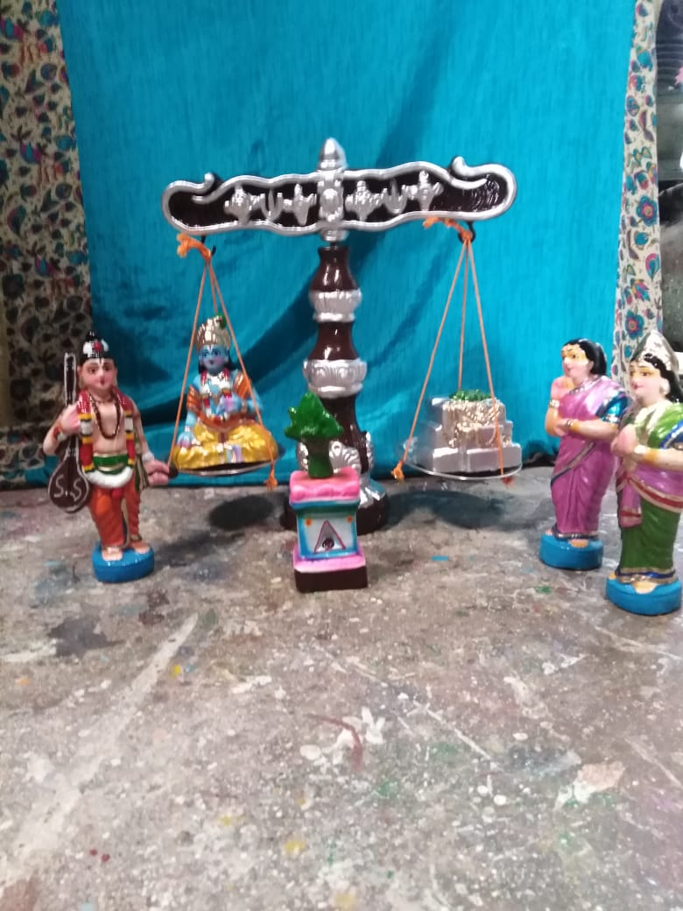 | THULAMBARAM SET  “Divine Thulambaram, reflecting the holy ritual of offering Tulasi to the Lord, filled with devotion and spiritual sanctity.” | BV63 | 125 USD

 | EARTHENWARE GOLU DOLLS CATALOUGE SHYAM HANDYKRAFTS | 100% Exports Free Shipping
SR No. | IMAGE | NAME AND DESCRIPTION | CODE No. | RATE IN USD
64 | 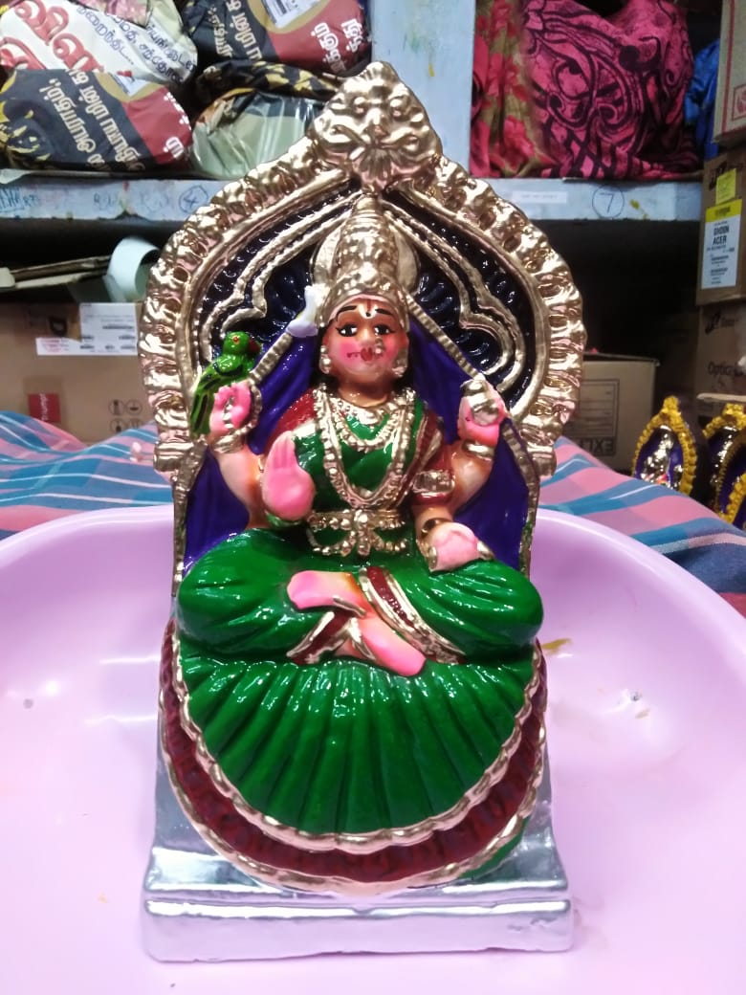 | KAMATCHI AMMAN  Blessed Kamatchi Amman, embodying the power of the Divine Mother who grants peace, prosperity, and spiritual upliftment.” | BV64 | 75 USD
65 | 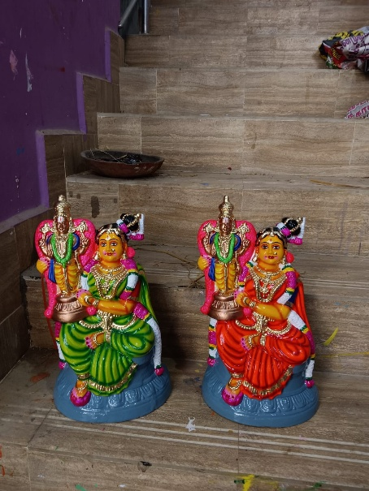 | AANDAAL PERUMAL SET  “Divine Aandaal Perumal, reflecting the supreme bhakti of Aandaal and the gracious presence of Lord Vishnu. | BV65 | 150 USD
66 | 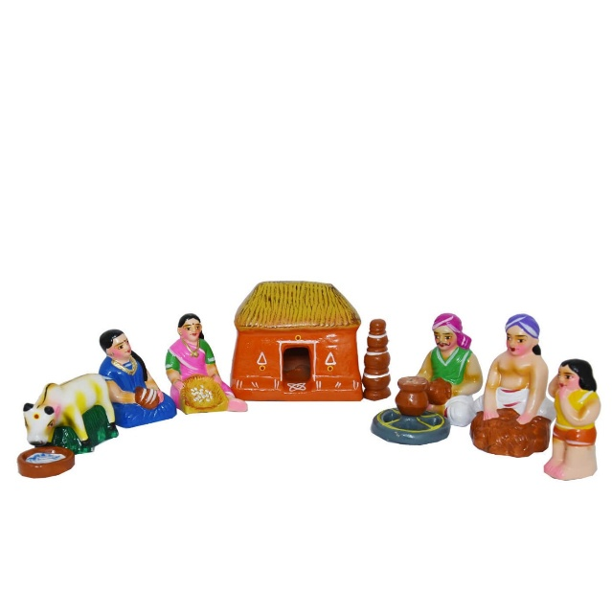 | KUZHAVAR SET  Sacred Kuzhavar set, depicting humble village folk, symbolizing simplicity, devotion, and the grace found in everyday life. | BV66 | 150 USD

 | EARTHENWARE GOLU DOLLS CATALOUGE SHYAM HANDYKRAFTS | 100% Exports  Free Shipping
SR No. | IMAGE | NAME AND DESCRIPTION | CODE No. | RATE IN USD
67 | 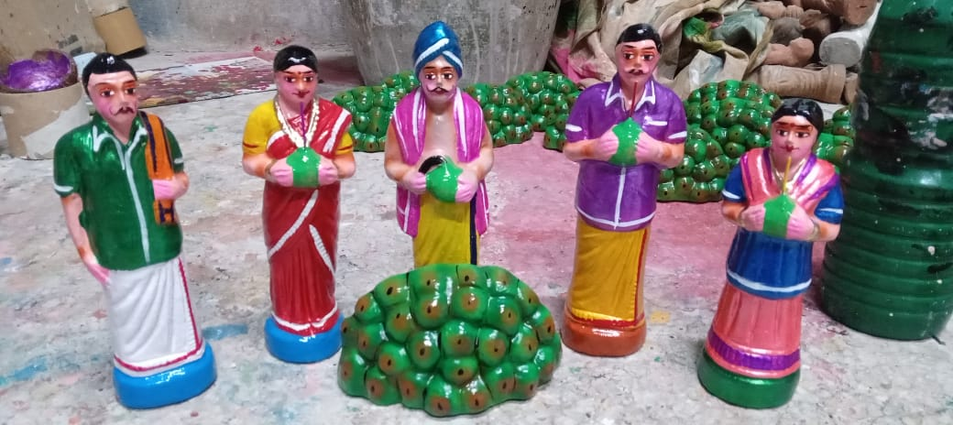 | ELENEER SET  Sacred Eleneer set, symbolizing the humble offering of tender coconut, invoking purity, nourishment, and divine blessings | BV67 | 110 USD
68 | 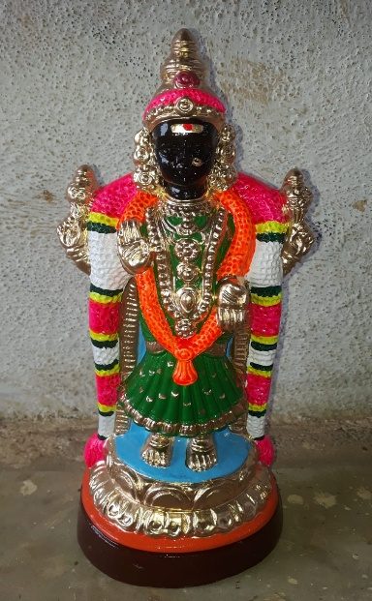 | AGILAANDESWARI  Sacred Akilandeswari, the supreme Divine Mother of Thiruvanaikaval, radiating boundless compassion, wisdom, and cosmic power. | BV68 | 99 USD
69 | 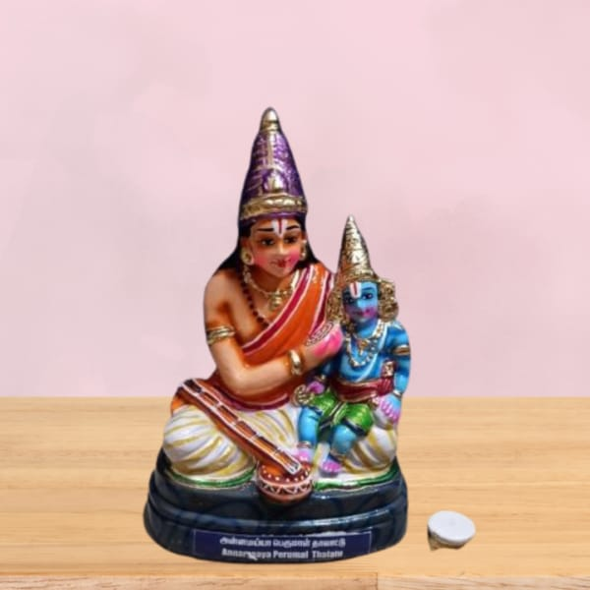 | NAMMAALWAR KRISHNAN  Blessed Nammaalwar Krishnan set, reflecting the profound bhakti of Nammaalwar and the compassionate presence of Lord Krishna. | BV69 | 110 USD

 | EARTHENWARE GOLU DOLLS CATALOUGE SHYAM HANDYKRAFTS | 100% Exports Free Shipping
SR No. | IMAGE | NAME AND DESCRIPTION | CODE No. | RATE IN USD
70 | 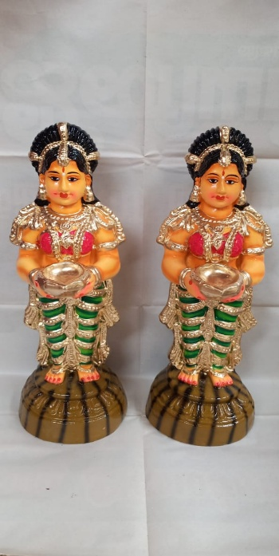 | PAAVAI VILAKKU JODI set  Sacred Paavai Vilakku Jodi set, depicting the graceful maidens holding lamps, symbolizing light, devotion, and auspicious beginnings. | BV70 | 99 USD
71 | 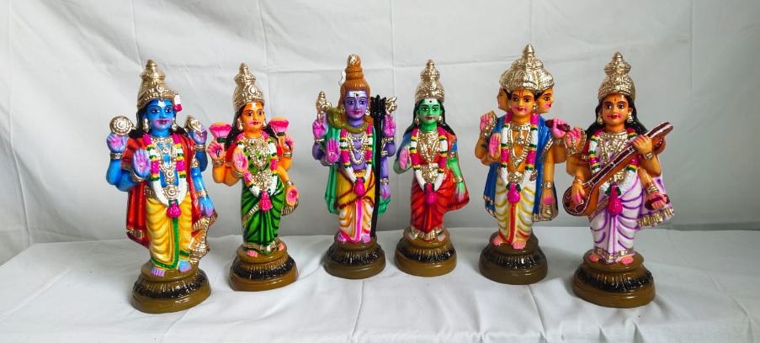 | MUM MOORTHIGAL SET  Blessed Mummoorthigal set, embodying the unity of creation, sustenance, and dissolution through the Trimurti. | BV71 | 350 USD
72 | 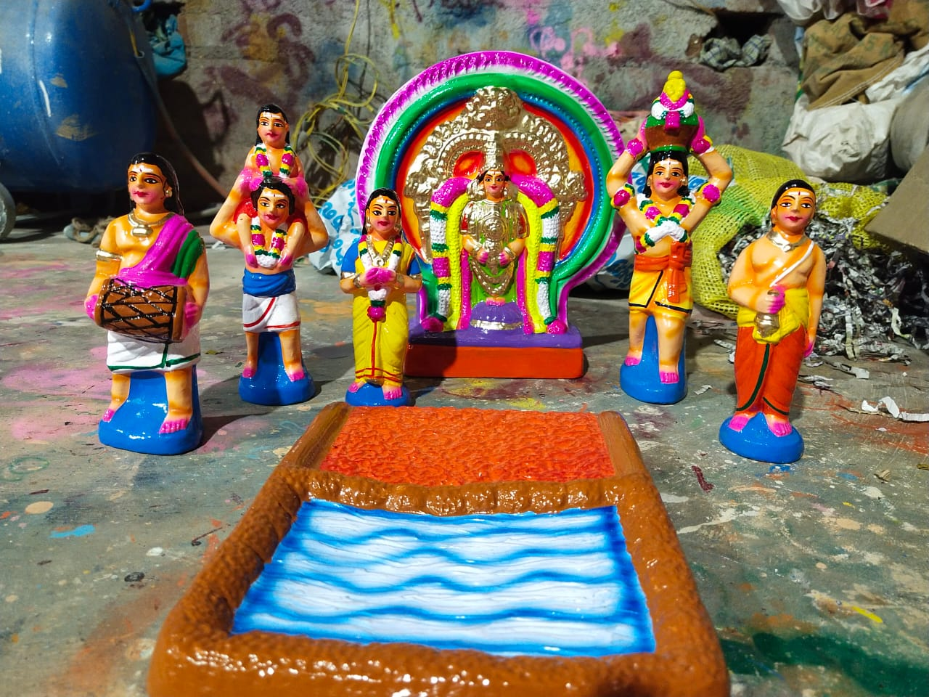 | THEEMITHI THIRUVIZHA SET  Divine Theemithi Thiruvizha, reflecting the powerful act of devotion where devotees walk through fire with absolute surrender to the Goddess | BV72 | 325 USD

 | EARTHENWARE GOLU DOLLS CATALOUGE SHYAM HANDYKRAFTS | 100% Exports Free Shipping
SR No. | IMAGE | NAME AND DESCRIPTION | CODE No. | RATE IN USD
73 | 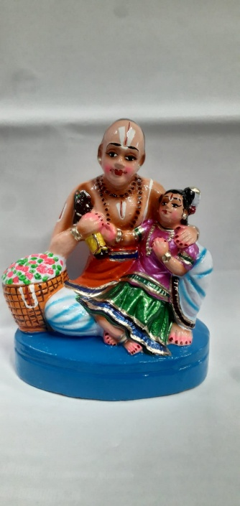 | PERIYALWAR ANDAL  Sacred Peri Alwar Andal, depicting the divine bond of devotion between the great saint Periyalwar and Goddess Andal | BV73 | 99 USD
74 | 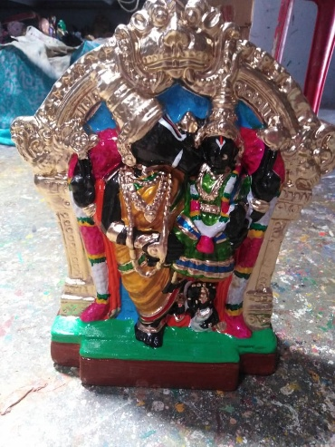 | NITHIYA KALYANA PERUMAL  Blessed Nithiya Kalyana Perumal, revered for granting timely marriages and harmonious family life. | BV74 | 110 USD
75 | 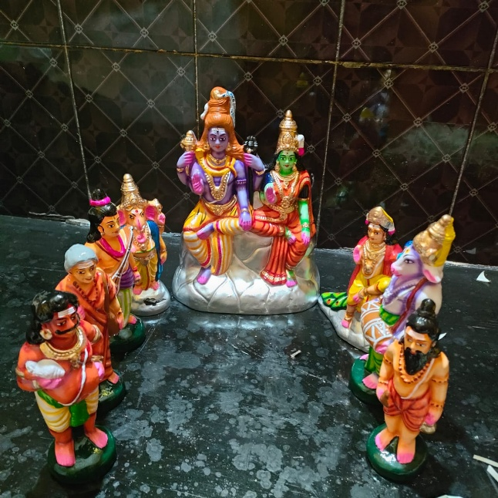 | KAILAAYAM SET  Blessed Kailaayam set, embodying the serene presence of Lord Shiva in His sacred Himalayan abode.” | BV75 | 300 USD

 | EARTHENWARE GOLU DOLLS CATALOUGE SHYAM HANDYKRAFTS | 100% Exports Free Shipping
SR No. | IMAGE | NAME AND DESCRIPTION | CODE No. | RATE IN USD
76 | 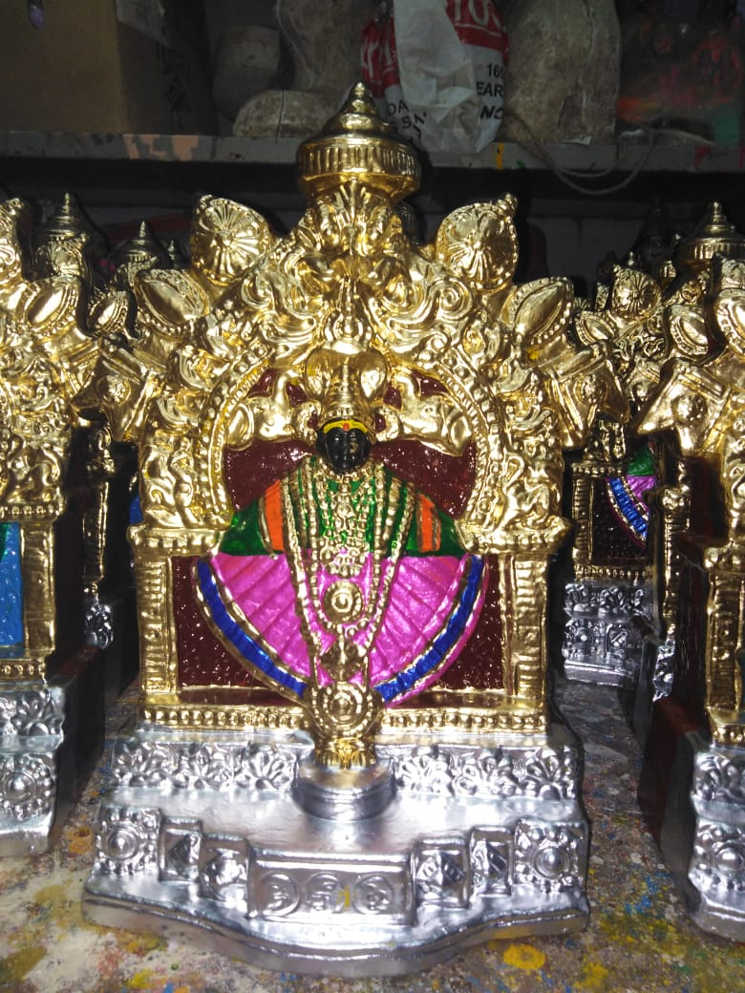 | KOLAPUR LAXMI  Sacred Kolapur Lakshmi, the divine Mahalakshmi of Kolhapur, bestowing wealth, prosperity, and auspicious blessings. | BV76 | 99 USD
77 | 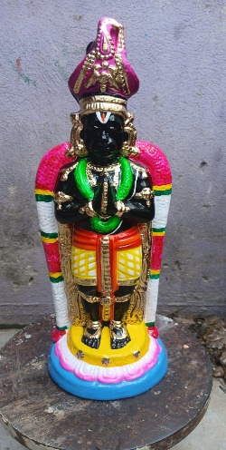 | NAMAKKAL ANJANEYAR  Divine Namakkal Anjaneyar, symbolizing unwavering bhakti and boundless courage in service of Lord Rama | BV77 | 75 USD
78 | 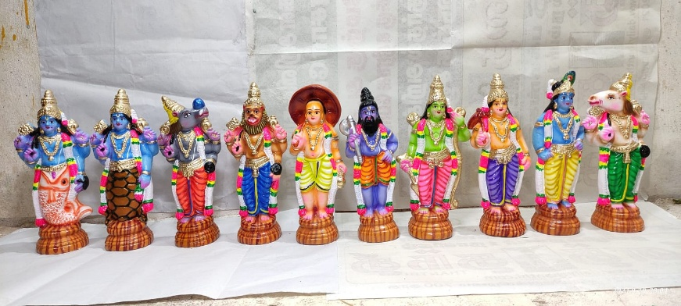 | DHASA AVATARAM SET  Sacred Dhasa Avataram set, depicting the ten divine incarnations of Lord Vishnu, symbolizing the protection of dharma across ages | BV78 | 175 USD

 | EARTHENWARE GOLU DOLLS CATALOUGE SHYAM HANDYKRAFTS | 100% Exports Free Shipping
SR No. | IMAGE | NAME AND DESCRIPTION | CODE No. | RATE IN USD
79 | 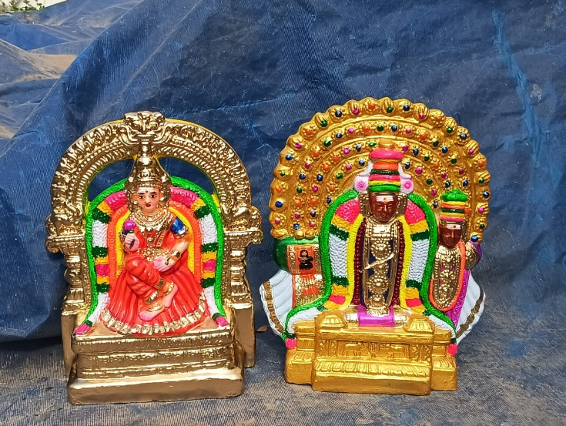 | Thiyaga Rajar Kamalaambigai  “Divine Thiyagaraja with Kamalambigai, symbolizing the union of Shiva and Shakti, bestowing harmony and divine blessings.” | BV79 | 200 USD
80 | 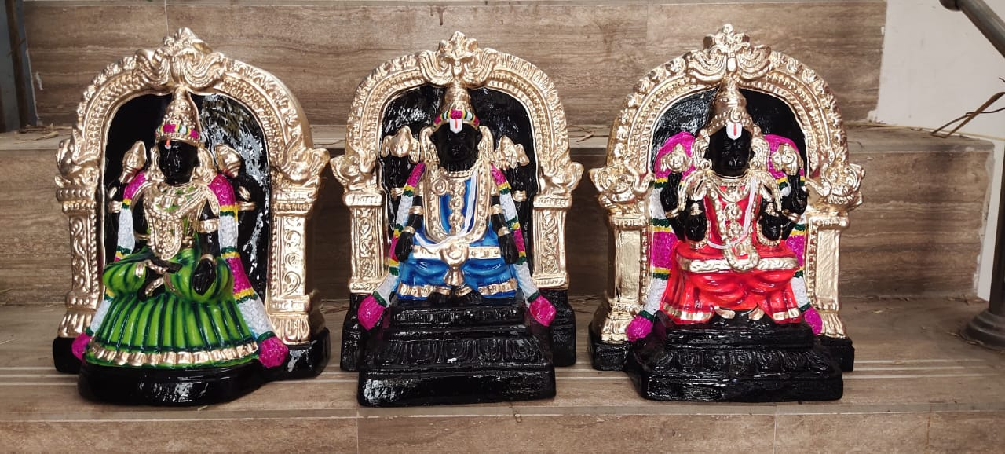 | SOLINGAR SET  A spiritually uplifting Solingar set, invoking strength, devotion, and the protective grace of the Lord. | BV80 | 200 USD
81 | 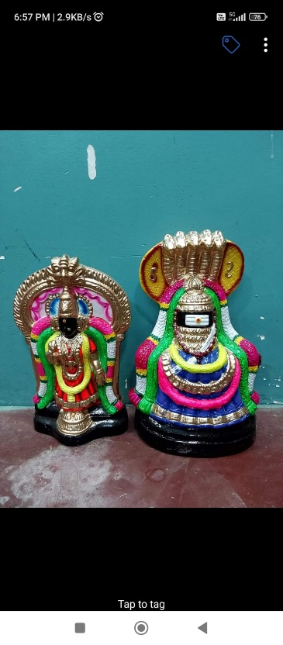 | ANNA MALAIYAR SET  Sacred  Annamalaiyar set, depicting Lord Arunachaleswarar of Tiruvannamalai, radiating the divine fire of wisdom and spiritual enlightenment | BV81 | 150 USD

 | EARTHENWARE GOLU DOLLS CATALOUGE SHYAM HANDYKRAFTS | 100% Exports Free Shipping
SR No. | IMAGE | NAME AND DESCRIPTION | CODE No. | RATE IN USD
82 | 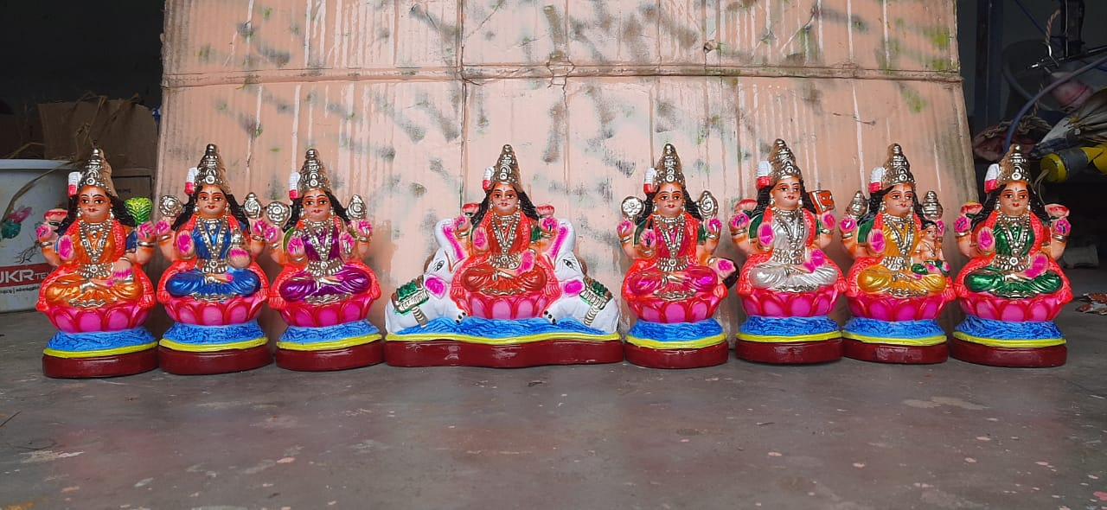 | ASTA LAXMI SET  “Sacred Ashta Lakshmi set, depicting the eight divine forms of Goddess Lakshmi, bestowing wealth, prosperity, courage, and wisdom.” | BV82 | 110 USD
83 | 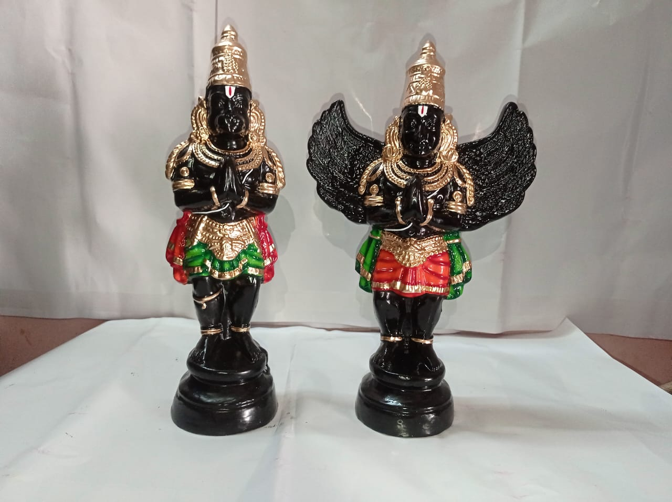 | KARUDAN ANGANEYAR SET  A spiritually powerful Karudan Anjaneyar set, invoking protection, devotion, and the blessings of Garuda and Hanuman | BV83 | 110 USD
84 | 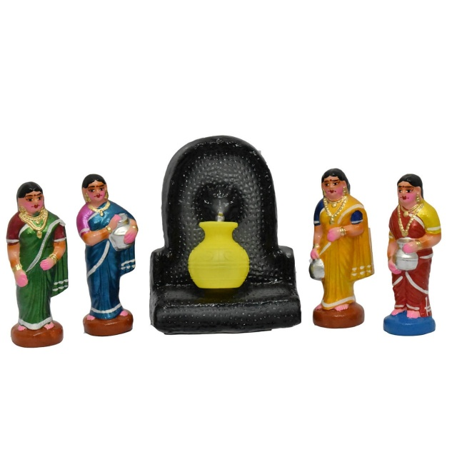 | THANEER KUZHAI SET  “Holy Thaneer Kuzhai scene, capturing the spiritual significance of water as a sacred and life-giving element.” | BV84 | 99 USD

 | EARTHENWARE GOLU DOLLS CATALOUGE SHYAM HANDYKRAFTS | 100% Exports Free Shipping
SR No. | IMAGE | NAME AND DESCRIPTION | CODE No. | RATE IN USD
85 | 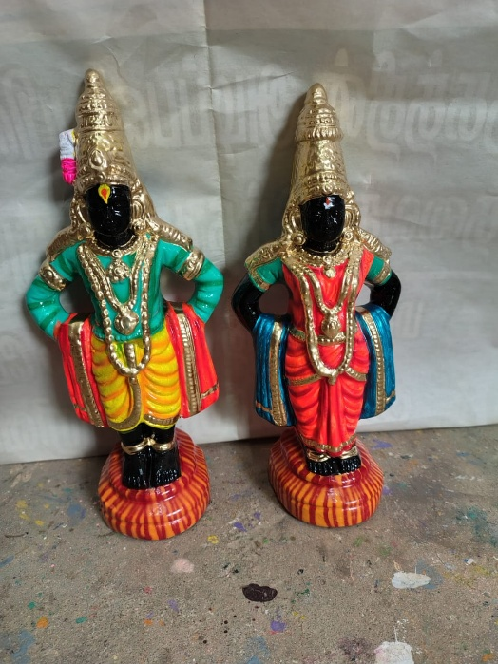 | Pandurangan Ragumaayi  “Holy Pandurangan Ragumaayi, reflecting the serene grace of Lord Vittala and Goddess Rukmini blessing devotees with peace.” | BV85 | 125 USD
86 | 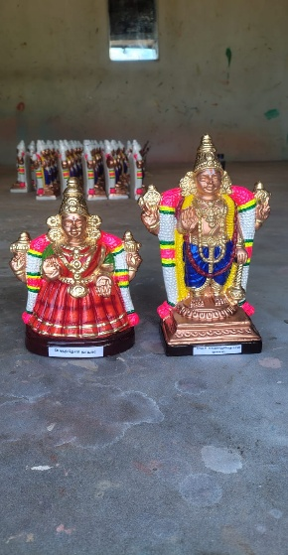 | Kanchi Varadar Thaayar  “Sacred Kanchi Varadar Thaayar, depicting Lord Varadaraja Perumal with Perundevi Thaayar, radiating divine grace, compassion, and prosperity.” | BV86 | 200 USD
87 | 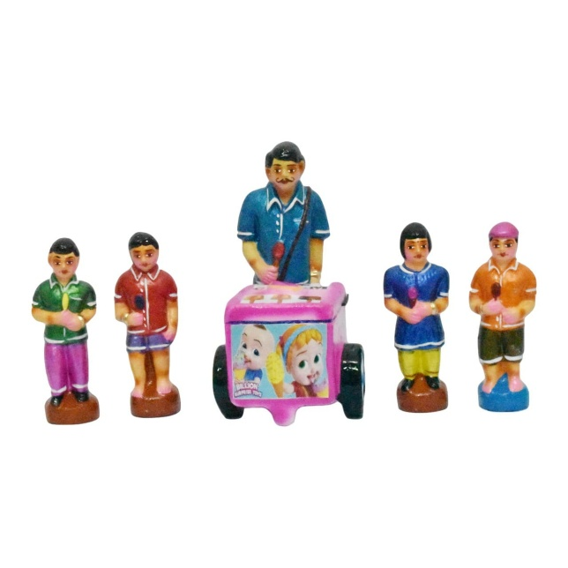 | ICE VANDI SET  Ice Vandi scene, reflecting the innocence and happiness found in everyday moments of life | BV87 | 125 USD

 | EARTHENWARE GOLU DOLLS CATALOUGE SHYAM HANDYKRAFTS | 100% Exports Free Shipping
SR No. | IMAGE | NAME AND DESCRIPTION | CODE No. | RATE IN USD
88 | 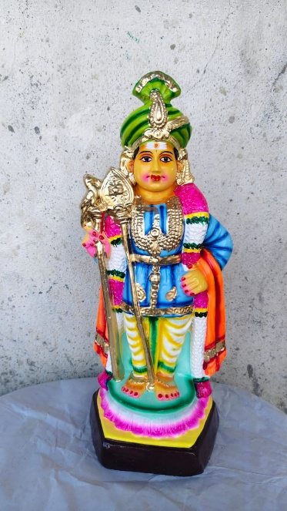 | RAJA ALANGARA MURUGAR  Blessed Raja Alangara Murugar, reflecting the royal alankaram of Lord Subramanya in all His divine glory. | BV88 | 90 USD
89 | 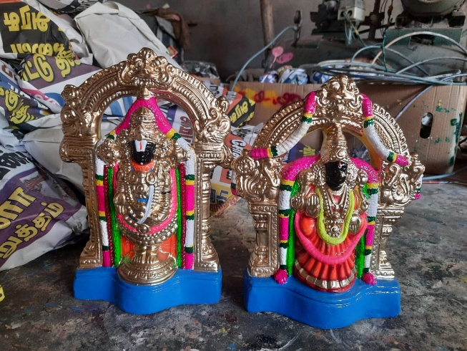 | PERUMAL THAAYAR SET  Holy Perumal Thaayar, reflecting the serene presence of Narayana and Mahalakshmi, bestowing peace and fulfillment. | BV89 | 200  USD
90 | 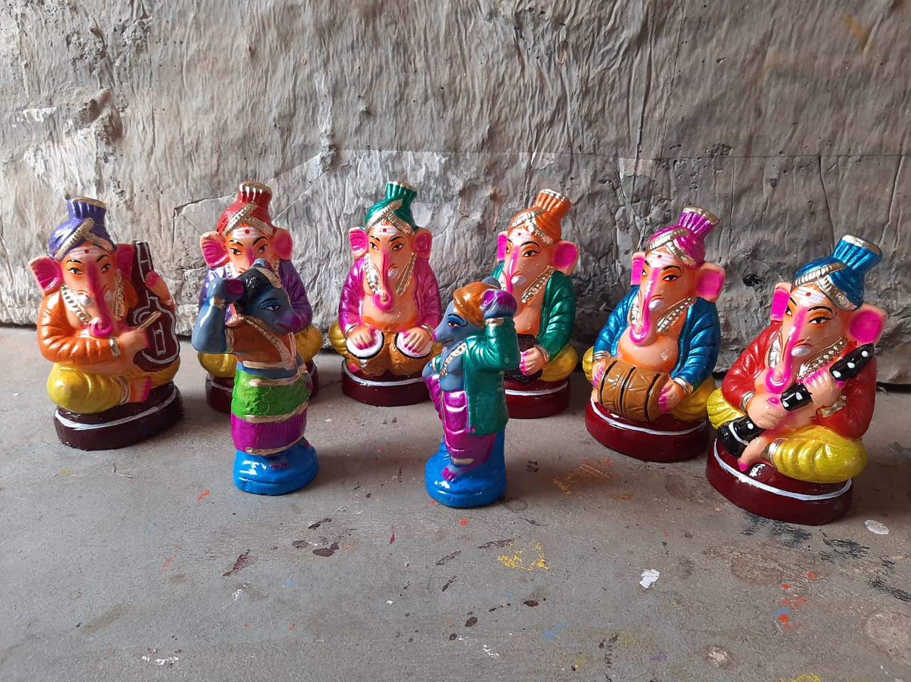 | ELI-DANCE SET  Holy Eli-Dance, (mouse dance)  capturing the playful spirit of creation where even the smallest beings celebrate the Divine, in Vinayagar’s presence. | BV90 | 200 USD

 | EARTHENWARE GOLU DOLLS CATALOUGE SHYAM HANDYKRAFTS | 100% Exports Free Shipping
SR No. | IMAGE | NAME AND DESCRIPTION | CODE No. | RATE IN USD
91 | 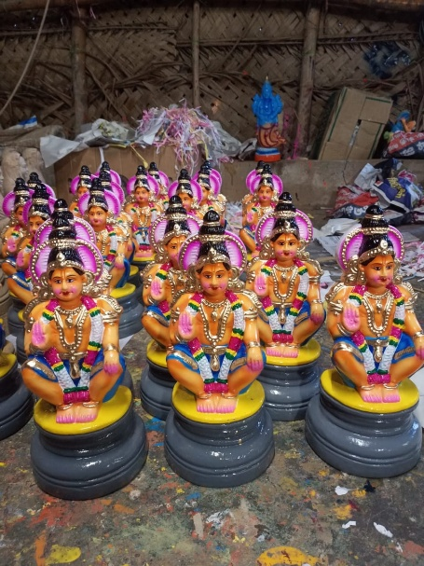 | AYYAPPAN SINGLE PIECE  Divine Ayyappan, of Sabarimala  symbolizing the union of Shiva and Vishnu, blessing devotees with strength, devotion, and righteousness.” | BV91 | 75 USD
92 | 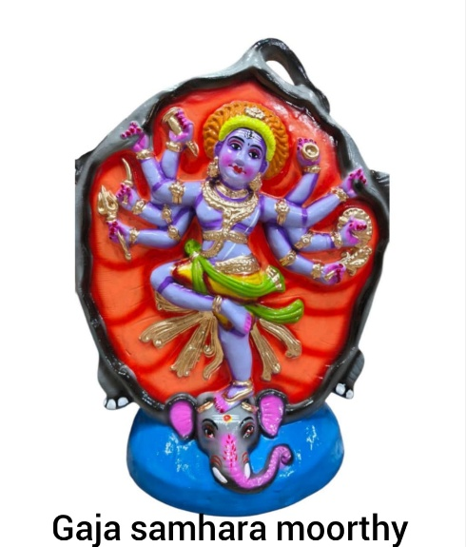 | GAJA SAMHAARA MOORTHY  Sacred Gaja Samhaara Moorthy, depicting Lord Shiva’s fierce form as He vanquishes the demon elephant, symbolizing the destruction of ego and evil. | BV92 | 99 USD
93 | 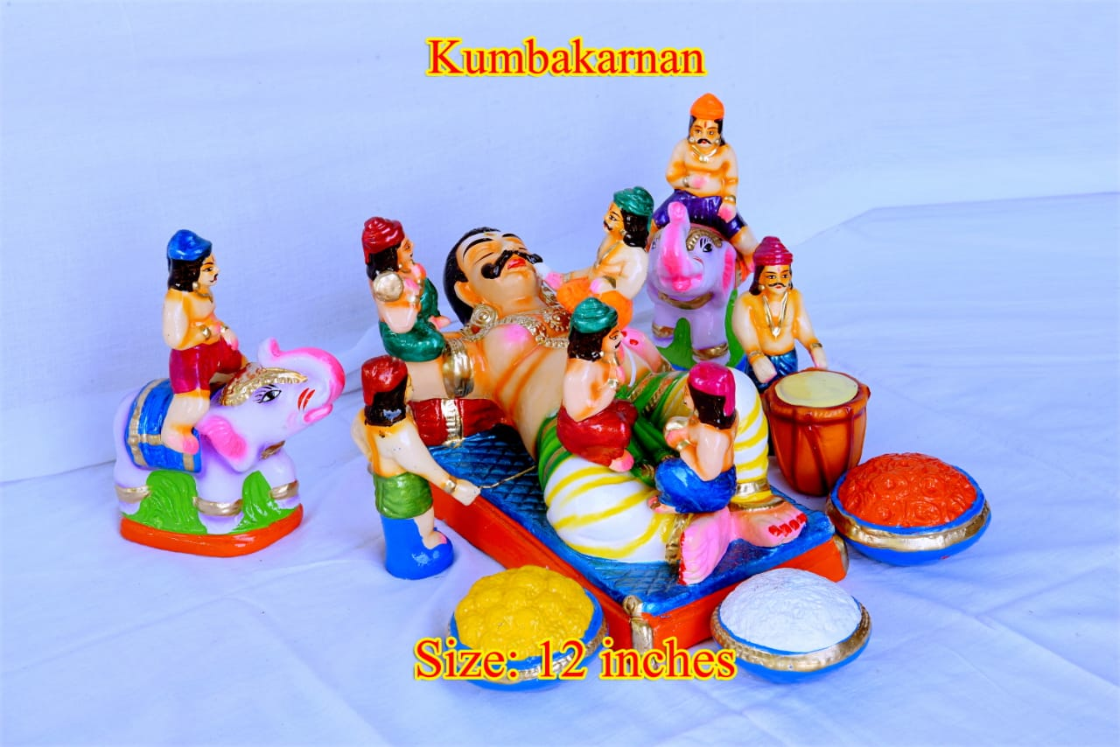 | KUMBAKARNAN SET  Kumbakarnan awakening set, embodying strength, fate, and the unfolding of divine will in the Ramayana. | BV93 | 150 USD

 | EARTHENWARE GOLU DOLLS CATALOUGE SHYAM HANDYKRAFTS | 100% Exports Free Shipping
SR No. | IMAGE | NAME AND DESCRIPTION | CODE No. | RATE IN USD
94 | 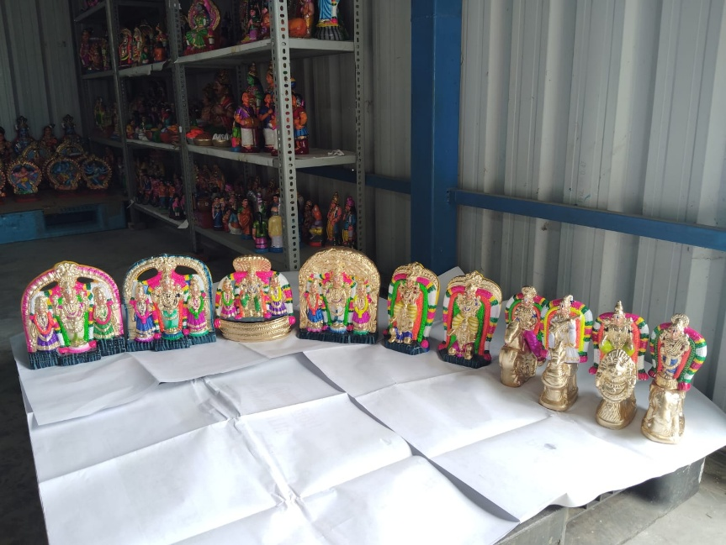 | BRAMMA URCHAVAM SET  Divine Bramma Urchavam, symbolizing the glorious annual festival where the Lord blesses devotees through sacred rituals and processions. | BV94 | 350 USD
95 | 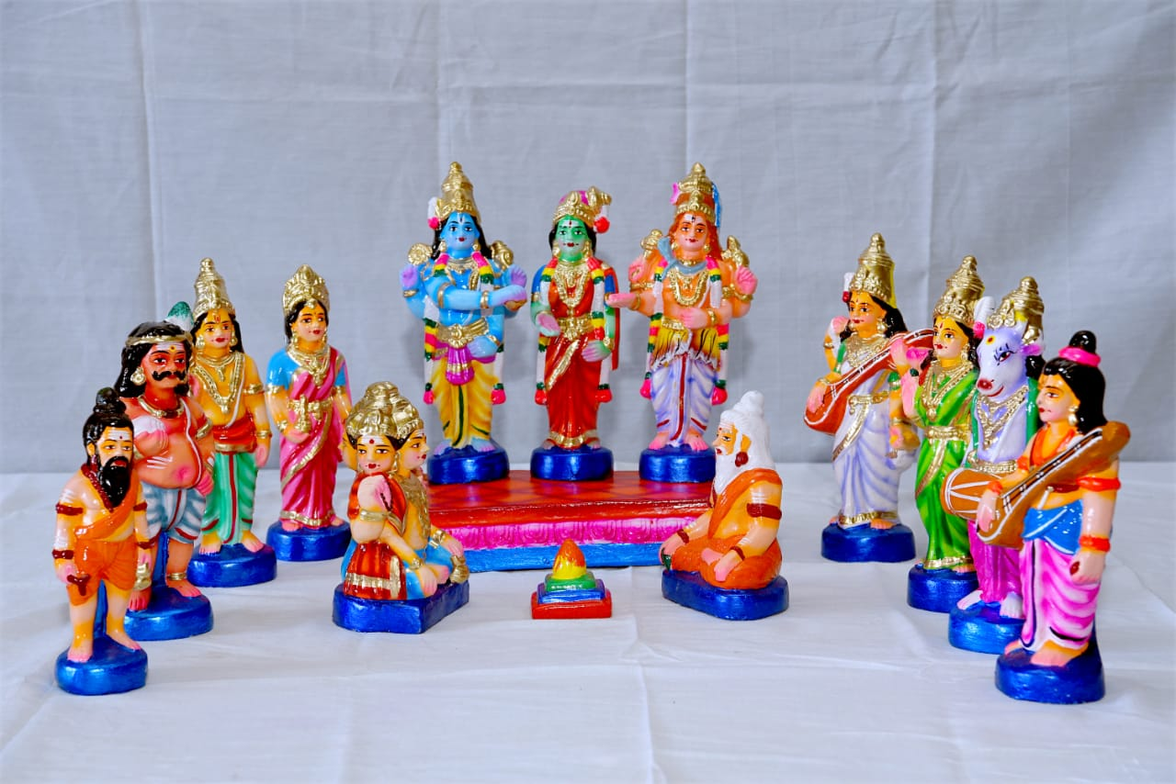 | MAHOTSAVAM SET  “Holy Mahotsavam, reflecting the unity of devotion, music, and celebration in a spiritually uplifting festival atmosphere” | BV95 | Coming soon
96 | 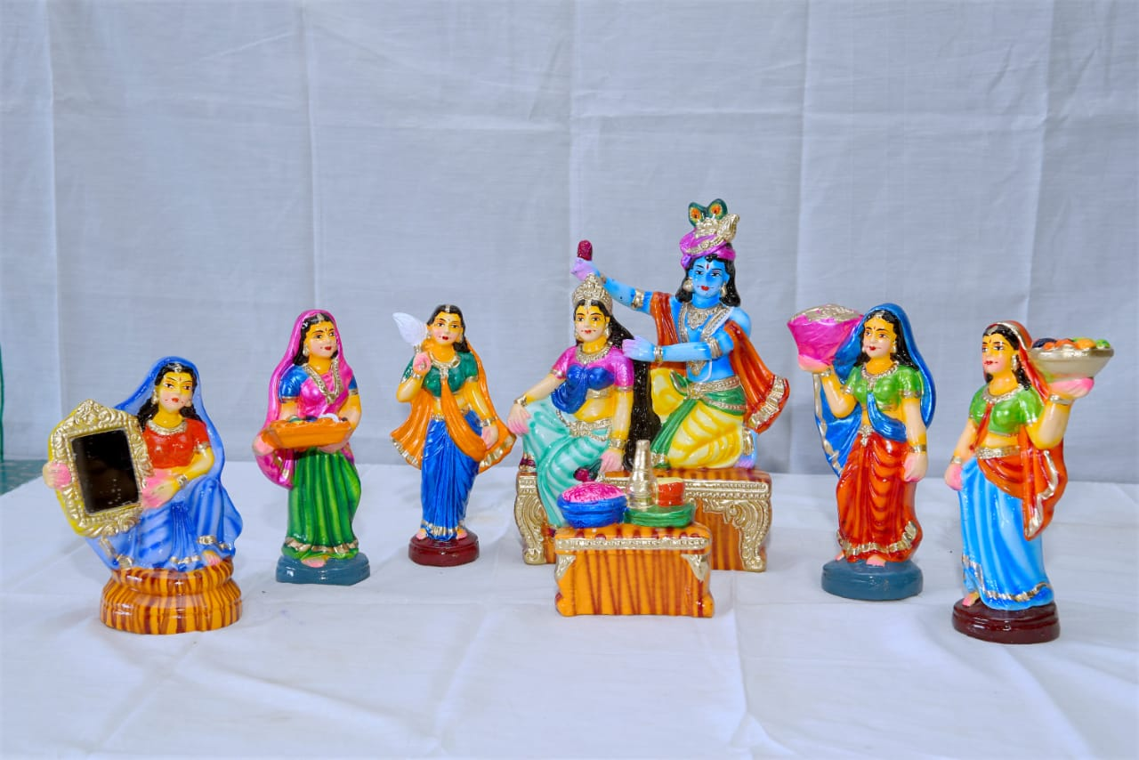 | RAADHAI ALANGAARAM SET  Blessed Raadhai Alangaaram set, reflecting the elegance and divine charm of Radha in her most graceful form | BV96 | 250 USD

 | EARTHENWARE GOLU DOLLS CATALOUGE SHYAM HANDYKRAFTS | 100% Exports Free Shipping
SR No. | IMAGE | NAME AND DESCRIPTION | CODE No. | RATE IN USD
97 | 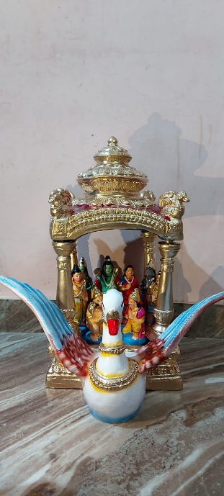 | VIMANAAM  Sacred Pushpak Vimaanam, the celestial chariot of the Ramayana, symbolizing divine travel, grandeur, and heavenly grace | BV97 | Coming soon
98 | 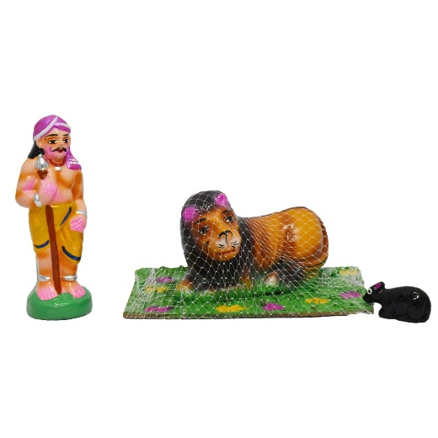 | VEDAN SET  Sacred Vedan set, depicting the humble mouse freeing the mighty lion, symbolizing that even the smallest act of compassion holds divine power. | BV98 | 110 USD
99 | 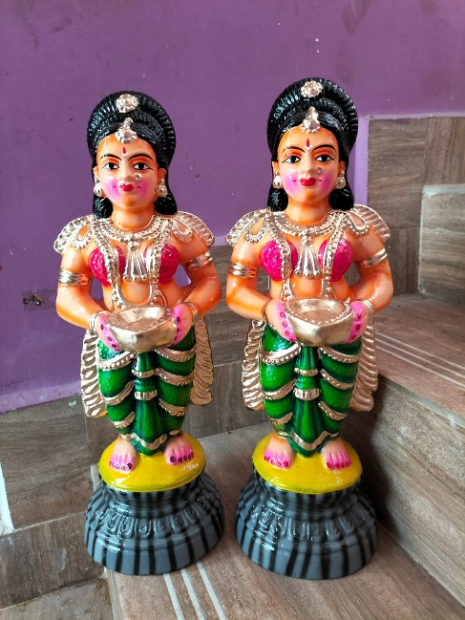 | PAAVAI VILAKKU JODI SET  “Sacred Paavai Vilakku Jodi set, depicting graceful maidens holding lamps, symbolizing divine light, purity, and auspicious beginnings.” | BV99 | 99 USD

 | EARTHENWARE GOLU DOLLS CATALOUGE SHYAM HANDYKRAFTS | 100% Exports Free Shipping
SR No. | IMAGE | NAME AND DESCRIPTION | CODE No. | RATE IN USD
100 | 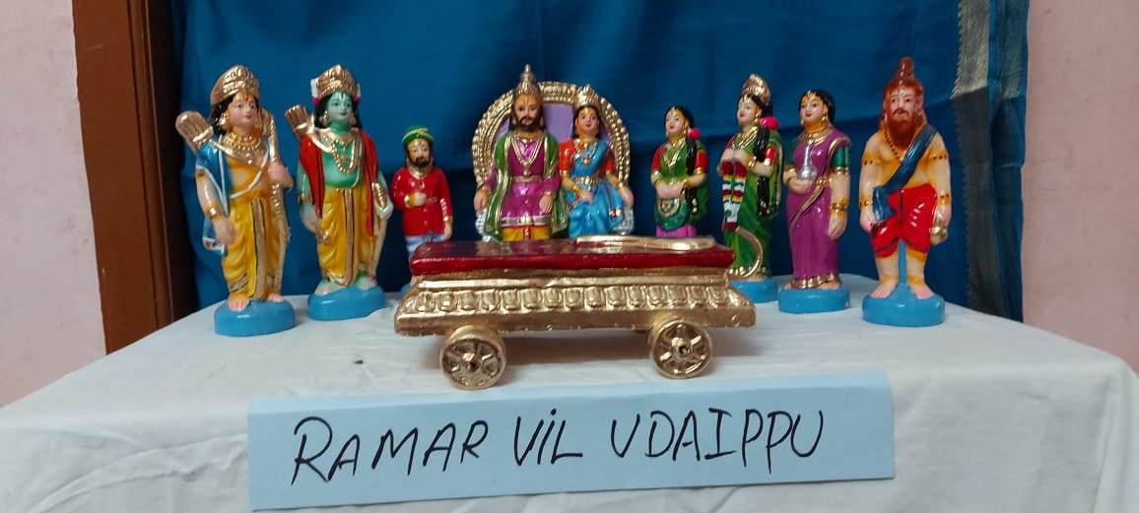 | RAMAR VIL UDAIPPU  Sacred Ramar Vil Udaippu, depicting Lord Rama breaking Shiva’s mighty bow, symbolizing divine strength and destined union with Sita | BV100 | 300 USD
101 | 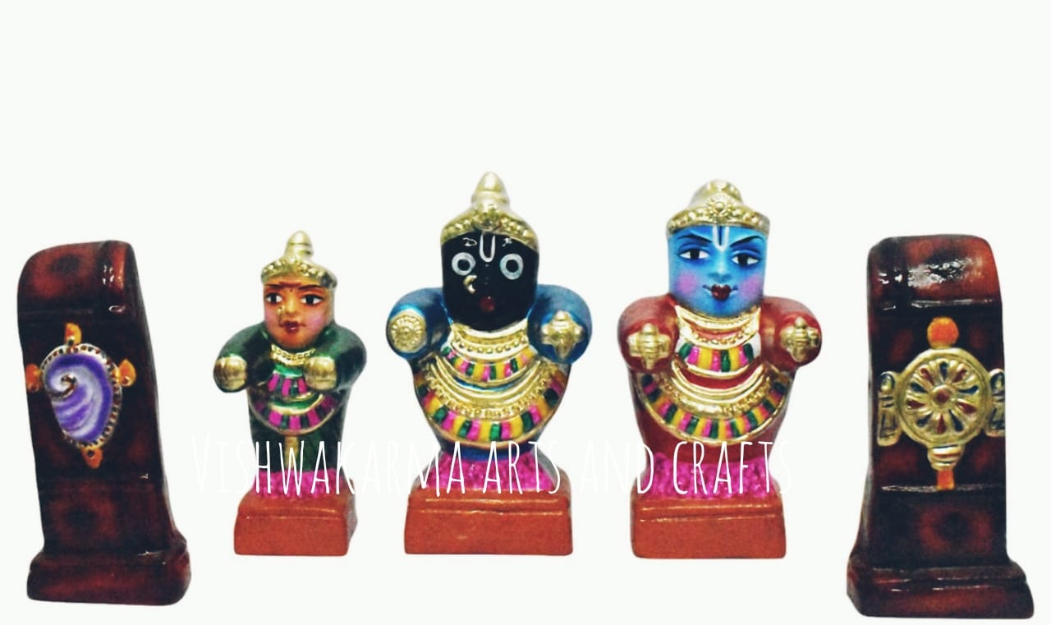 | Poori Jagannaadar Set  Sacred Poori Jagannaadar set, depicting Lord Jagannath of Puri with His divine siblings, radiating compassion, devotion, and universal grace | BV101 | 110 USD
102 | 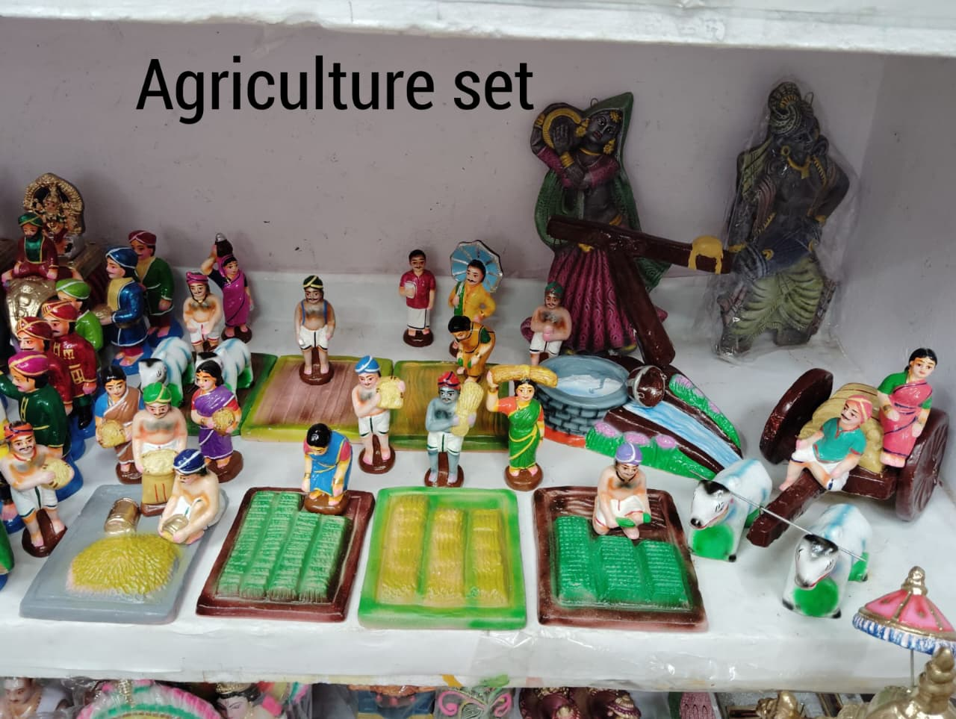 | AGRICULTURE SET  Divine Agriculture scene, reflecting the noble act of farming, sustained by faith, hard work, and nature’s grace. | BV102 | 350 USD

 | EARTHENWARE GOLU DOLLS CATALOUGE SHYAM HANDYKRAFTS | 100% Exports Free Shipping
SR No. | IMAGE | NAME AND DESCRIPTION | CODE No. | RATE IN USD
103 | 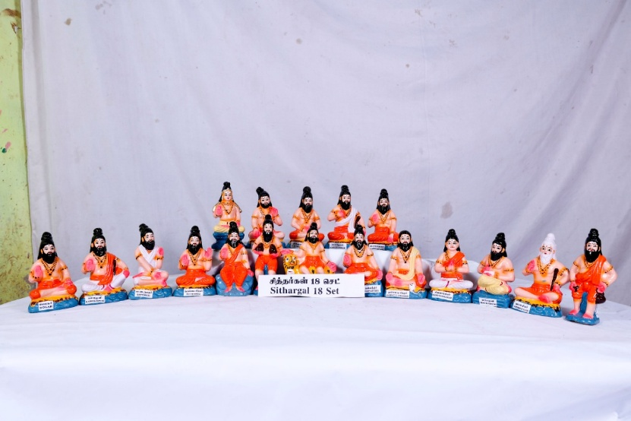 | SITHARGAL SET  A spiritually profound Sithargal set, invoking wisdom, healing energy, and the grace of enlightened masters | BV103 | 350 USD
104 | 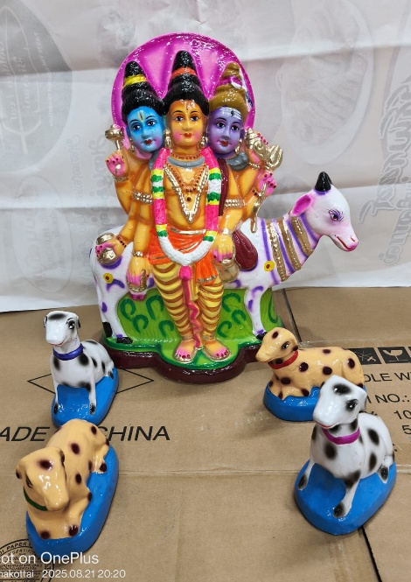 | Thattathreyar Set  “Sacred Thattathreyar set, depicting Lord Dattatreya, the divine Trinity incarnate, embodying Brahma, Vishnu, and Shiva in one form.” | BV104 | 150 USD
105 | 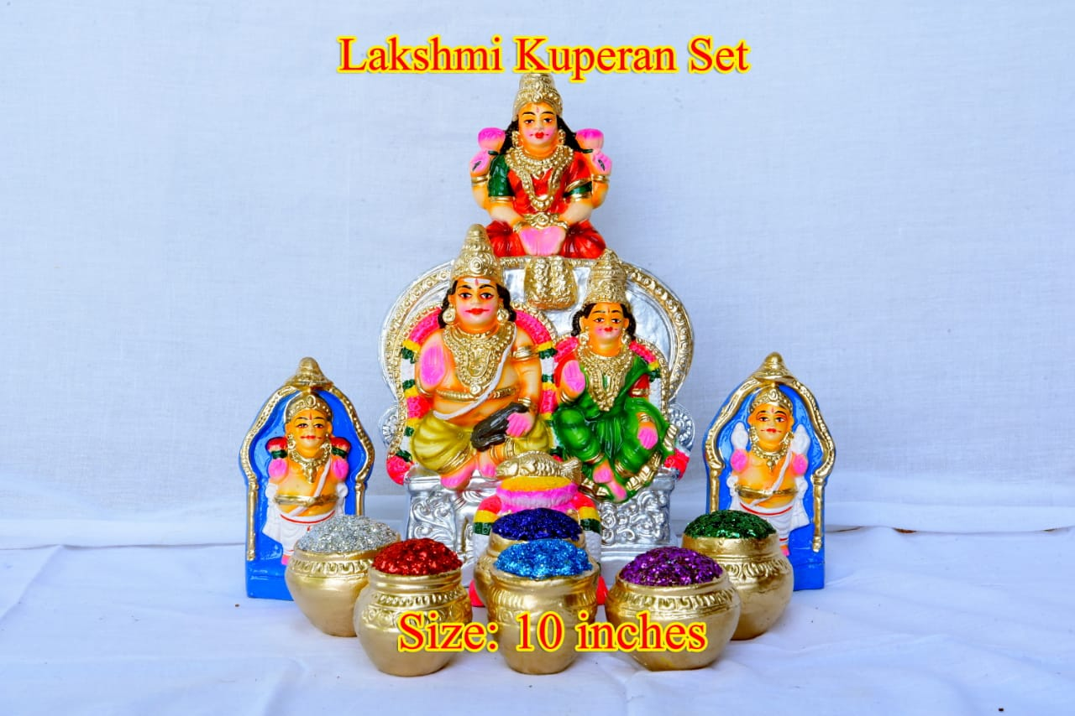 | Laxmi Kuberan Set  Divine Lakshmi Kuberan, symbolizing the union of fortune and treasury, blessing devotees with financial growth and well-being. | BV105 | 110 USD

 | EARTHENWARE GOLU DOLLS CATALOUGE SHYAM HANDYKRAFTS | 100% Exports Free Shipping
SR No. | IMAGE | NAME AND DESCRIPTION | CODE No. | RATE IN USD
106 | 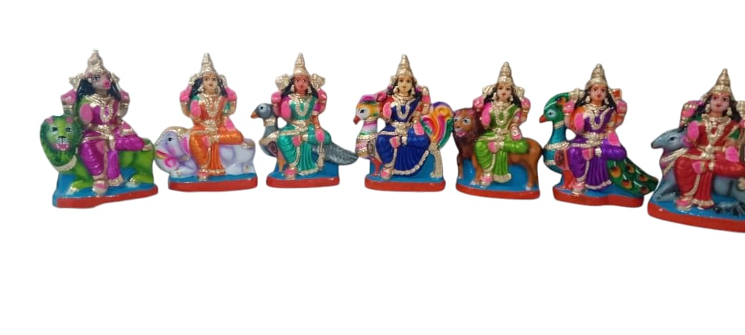 | Saptha Maadha Set  “Sacred Saptha Maadha set, depicting the seven Divine Mothers, radiating supreme Shakti, protection, and cosmic balance” | BV106 | 350 USD
107 | 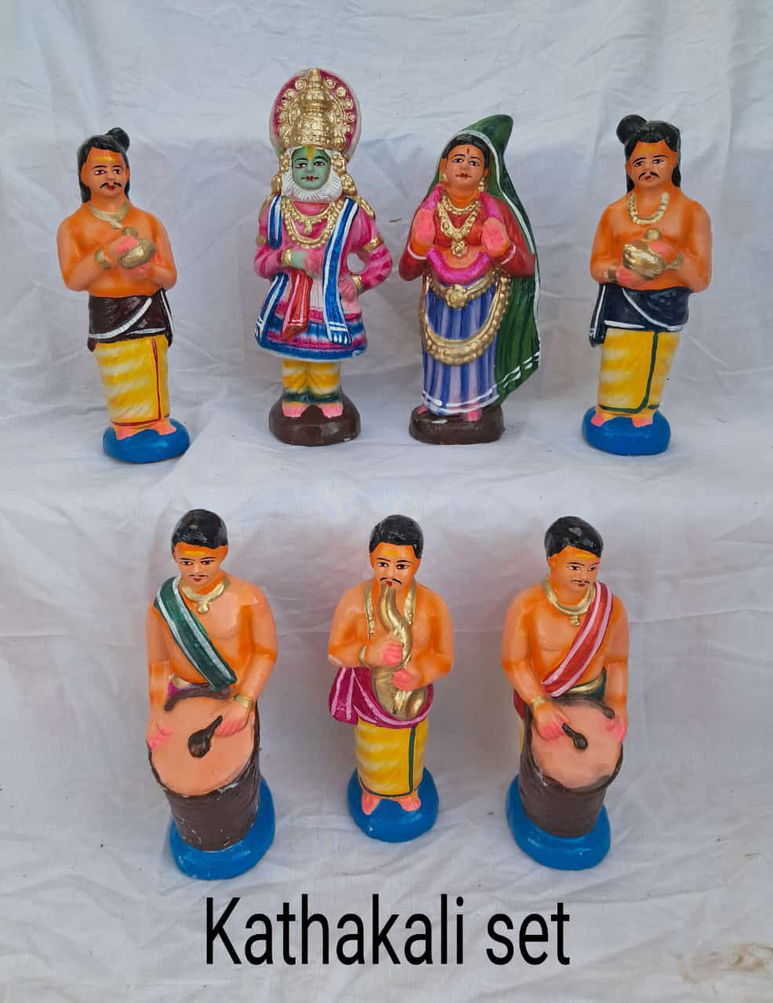 | KATHAKALI SET  Sacred Kathakali set, depicting the classical dance drama that brings divine stories to life through vibrant expression and devotion. | BV107 | 300 USD
108 | 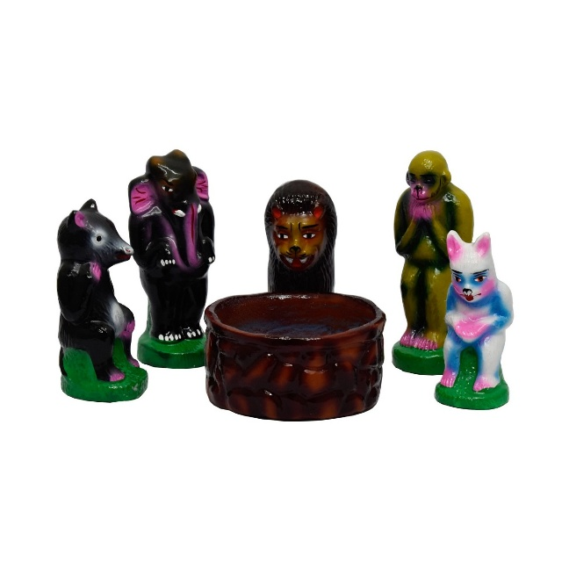 | JANTUGAL SET  Divine Jantugal scene, reflecting the coexistence of all beings under the compassionate grace of the Divine | BV108 | Coming soon

 | EARTHENWARE GOLU DOLLS CATALOUGE SHYAM HANDYKRAFTS | 100% Exports Free Shipping
SR No. | IMAGE | NAME AND DESCRIPTION | CODE No. | RATE IN USD
109 | 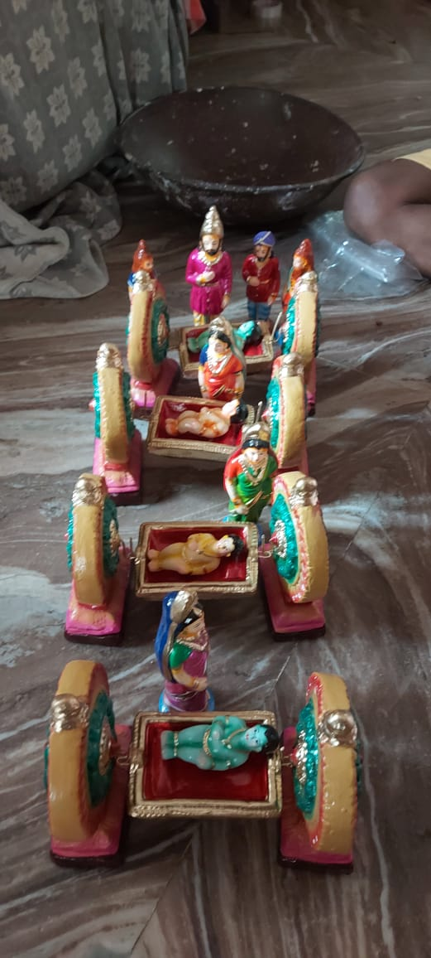 | KUZHANDAIGAL CRADLES SET  Blessed Kuzhandaigal Cradles set, embodying love, care, and the auspicious beginnings of life under divine protection | BV109 | Coming soon
110 | 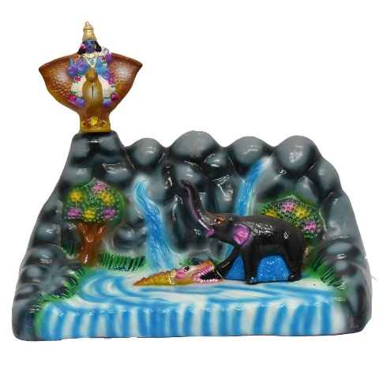 | GAJENDRA MOTCHAM SET  Sacred Gajendra Motcham set, depicting Lord Vishnu rescuing the elephant king from the crocodile, symbolizing divine grace and surrender | BV110 | 220 USD
111 | 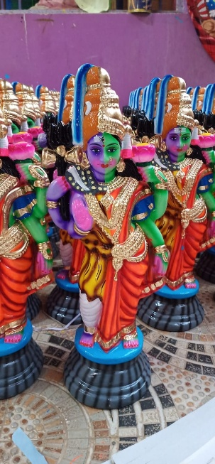 | Artha Nareeswarar  Divine Ardha Nareeswara, embodying the unity of Purusha and Prakriti, radiating harmony, creation, and cosmic balance. | BV111 | 99 USD

 | EARTHENWARE GOLU DOLLS CATALOUGE  SHYAM HANDYKRAFTS | 100% Exports Free Shipping
SR No. | IMAGE | NAME AND DESCRIPTION | CODE No. | RATE IN USD
112 | 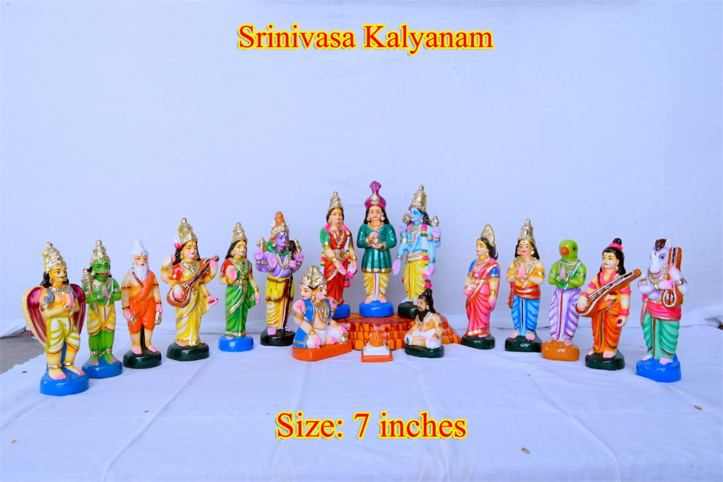 | Srinivaasa Kalyanam Set  “Sacred Srinivaasa Kalyanam set, depicting the divine wedding of Lord Venkateswara and Goddess Padmavathi, radiating auspiciousness and grace.” | BV112 | 180 USD
113 | 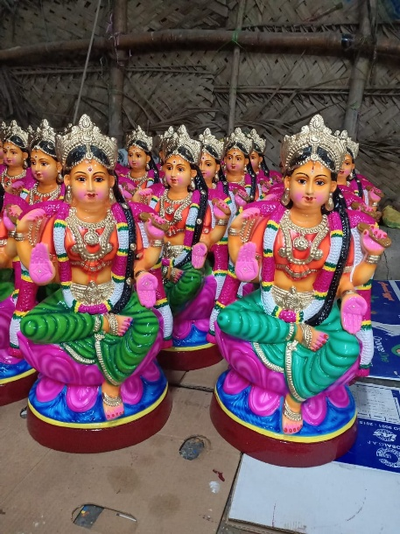 | Kuzhandai Bala Single piece  Holy Kuzhandai Bala, reflecting the tender charm of the child form that fills hearts with devotion and joy | BV113 | 90 USD
114 | 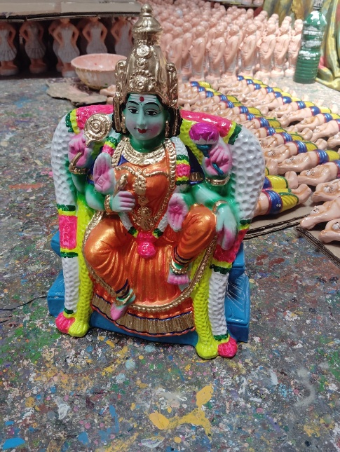 | Amman  “Blessed Amman, symbolizing the all-powerful Mother who removes obstacles and grants peace and abundance.” | BV114 | Coming soon

 | EARTHENWARE GOLU DOLLS CATALOUGE SHYAM HANDYKRAFTS | 100% Exports Free Shipping
SR No. | IMAGE | NAME AND DESCRIPTION | CODE No. | RATE IN USD
115 | 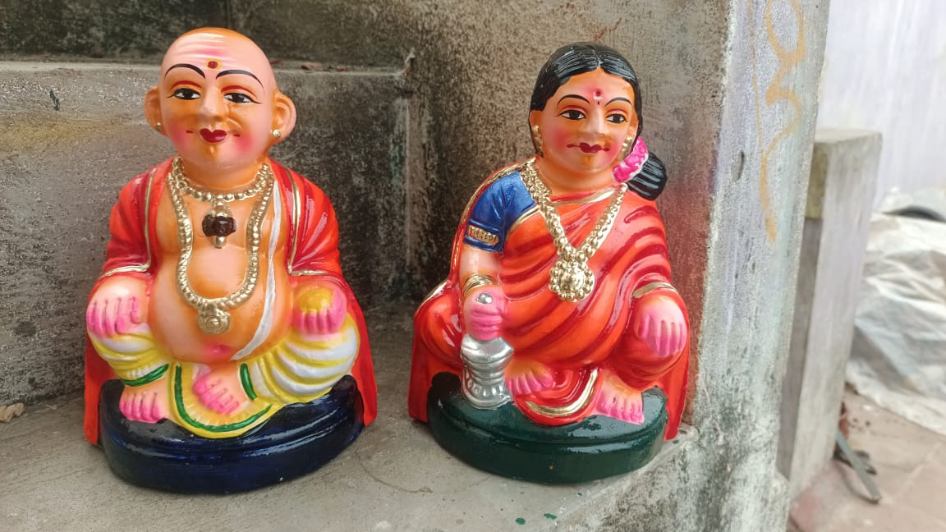 | Taatha Paati Set  Blessed Taatha Paati set, reflecting the timeless bond of family, filled with affection, wisdom, and sacred blessings | Bv115 | 75  USD
116 | 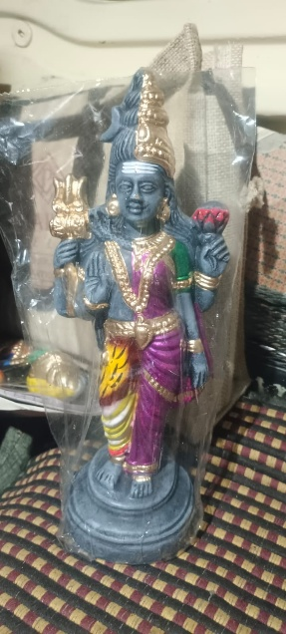 | Artha Nareeswarar  Divine Ardha Nareeswara, embodying the oneness of masculine and feminine energies that sustain creation | Bv116 | 99 USD
117 | 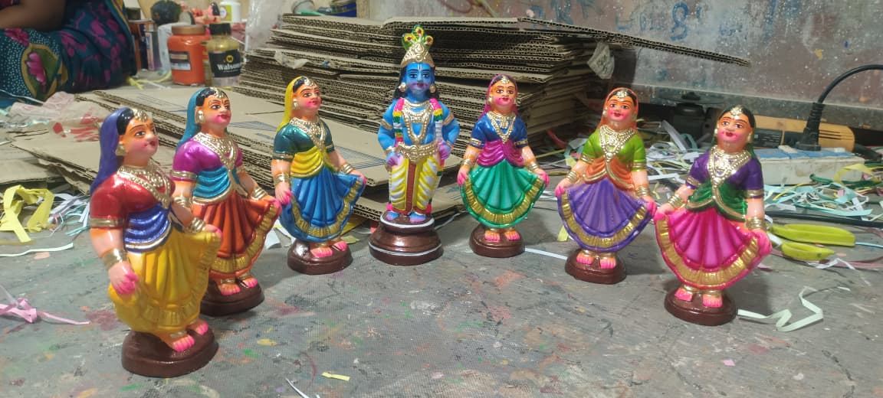 | Gopi Dance Set  Sacred Gopi Dance set, depicting the divine Raas Leela where Gopis dance in blissful devotion around Lord Krishna. | Bv117 | 350 USD

 | EARTHENWARE GOLU DOLLS CATALOUGE SHYAM HANDYKRAFTS | 100% Exports Free Shipping
SR No. | IMAGE | NAME AND DESCRIPTION | CODE No. | RATE IN USD
118 | 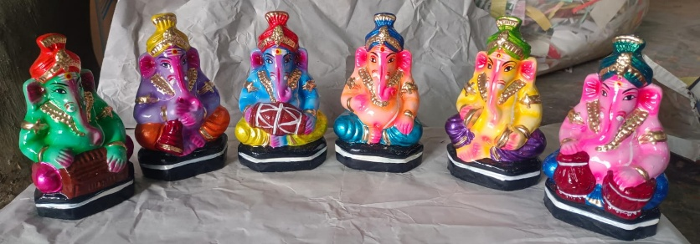 | VINAYAGAR MUSIC SET  “Sacred Vinayagar Music set, depicting six divine forms of Lord Ganesha playing instruments, radiating harmony, joy, and auspicious blessings” | BV118 | 350 USD
119 | 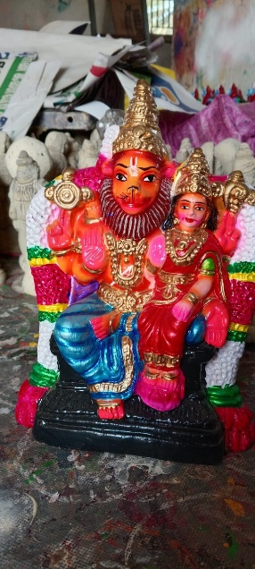 | LAXMI NARASIMMAR SET  Blessed Lakshmi Narasimhar set, embodying the Lord’s protective strength and the soothing presence of Mahalakshmi | BV119 | 70 USD
120 | 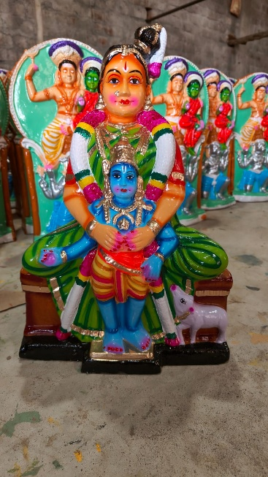 | NAM PERUMAL AANDAL  A spiritually enchanting Nam Perumal Andal, invoking love, devotion, and the divine blessings of Perumal and Andal | BV120 | 99 USD

 | EARTHENWARE GOLU DOLLS CATALOUGE SHYAM HANDYKRAFTS | 100% Exports Free Shipping
SR No. | IMAGE | NAME AND DESCRIPTION | CODE No. | RATE IN USD
121 | 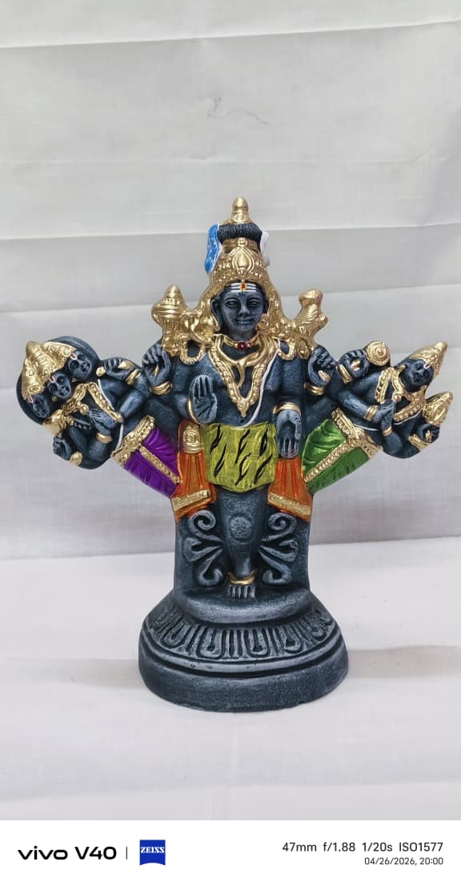 | TRIMOORTHI  Divine Trimurthi, embodying the cosmic trinity in one form, radiating supreme balance and universal harmony | BV121 | Coming soon
122 | 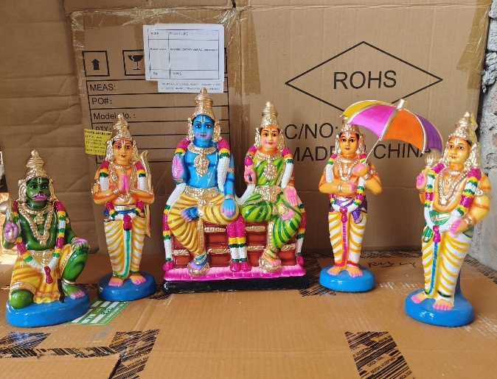 | RAMAR SITA SET  Sacred Ramar Sita set, depicting Lord Rama with Goddess Sita, radiating dharma, love, and divine grace | BV122 | Coming soon
123 | 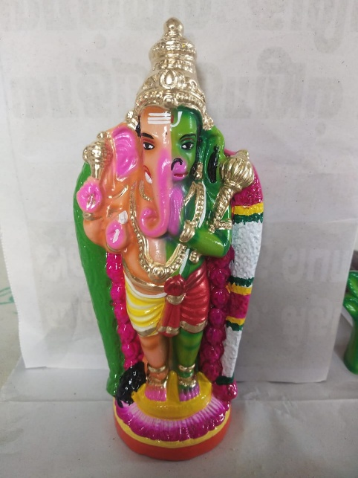 | ADI AANDA PRABU  “Sacred Adi Aanda Prabu, a rare divine form uniting multiple deities, radiating supreme power, protection, and cosmic harmony. | BV123 | 99 USD

 | EARTHENWARE GOLU DOLLS CATALOUGE SHYAM HANDYKRAFTS | 100% Exports Free Shipping
SR No. | IMAGE | NAME AND DESCRIPTION | CODE No. | RATE IN USD
124 | 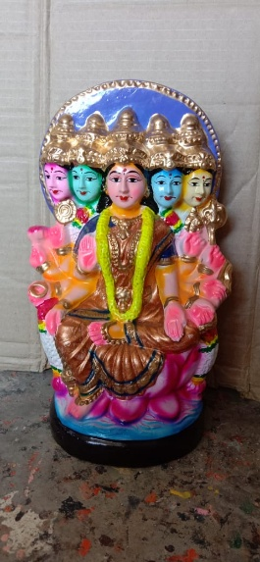 | GAYATRI  Divine Gayatri, embodying the eternal mantra that illuminates the mind and guides seekers towards truth and wisdom. | Bv124 | 110 USD
125 | 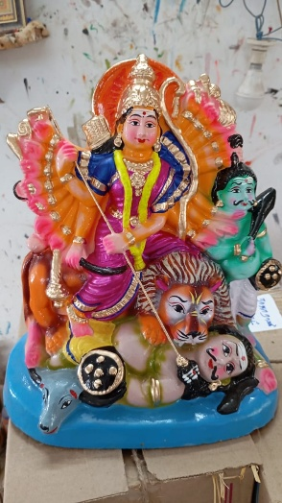 | Mahishasoora Marthini  “Sacred Mahishasoora Marthini, the fierce form of Goddess Durga who vanquishes the buffalo demon, symbolizing the triumph of good over evil.” | BV125 | 99 USD
126 | 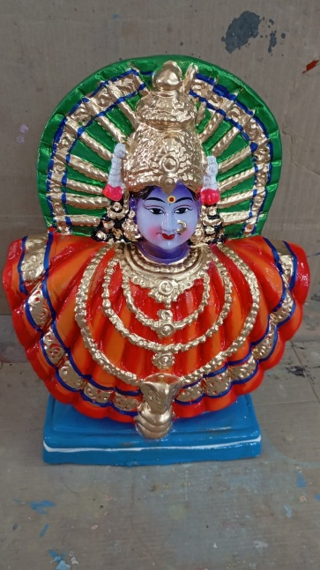 | RENUKA DEVI  Sacred Renuka Devi, the compassionate Divine Mother, radiating protection, strength, and boundless grace to her devotee | BV126 | 100 USD

 | EARTHENWARE GOLU DOLLS CATALOUGE SHYAM HANDYKRAFTS | 100% Exports Free Shipping
SR No. | IMAGE | NAME AND DESCRIPTION | CODE No. | RATE IN USD
127 | 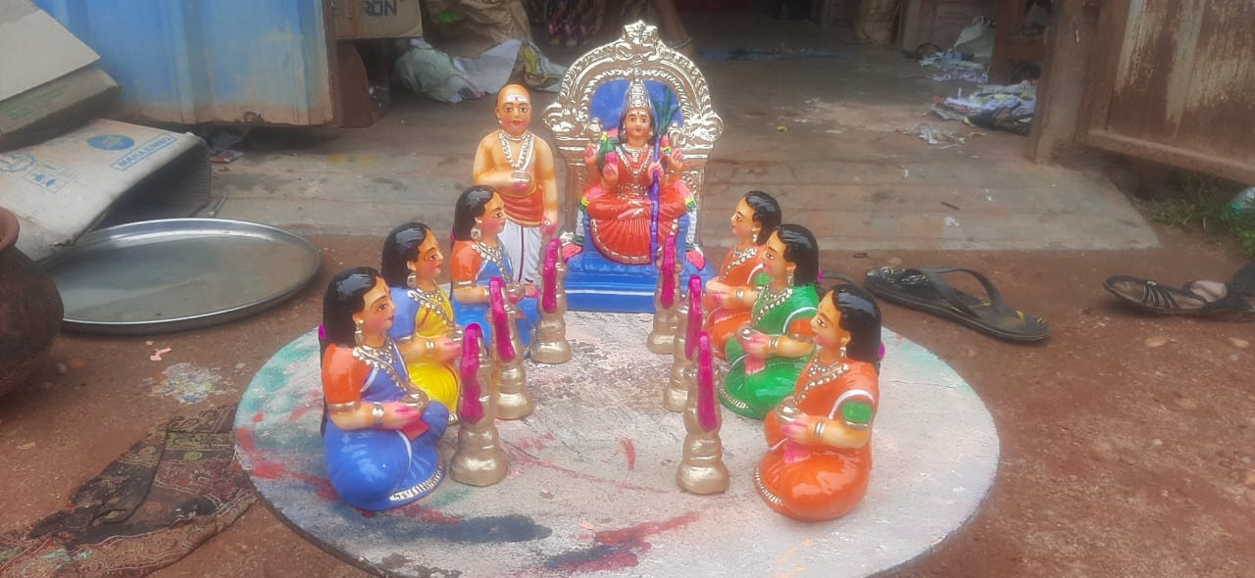 | Kaamaatchi Vilakku Poojai Set  “Holy Kamatchi Vilakku Poojai, reflecting the serene ritual of lighting lamps to invoke the compassionate grace of the Goddess” | BV127 | 300 USD
128 | 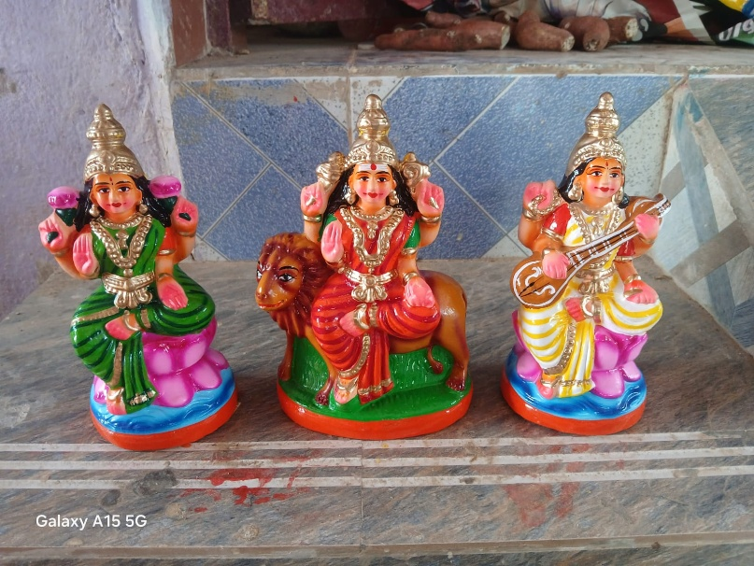 | LAXMI DURGA SARASWATI SET  Divine Lakshmi Durga and Saraswati, symbolizing prosperity, power, and knowledge in perfect harmony | BV128 | 250 USD
129 | 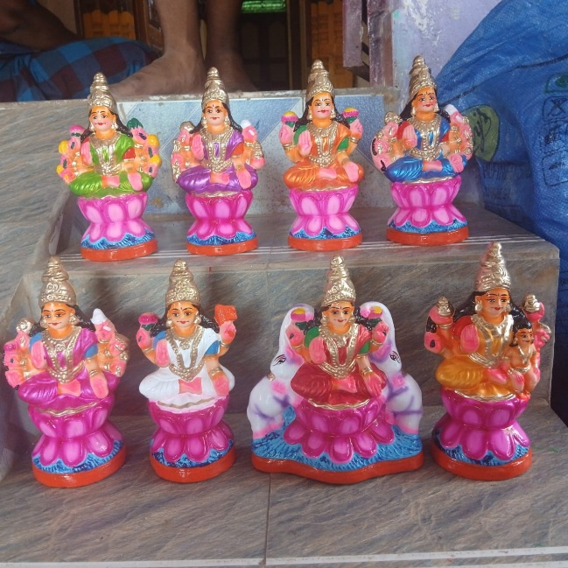 | ASTA LAXMI SET  Holy Ashta Lakshmi, reflecting wealth, strength, success, fertility, victory, and wisdom through the Divine Mother | BV129 | 110 USD

 | EARTHENWARE GOLU DOLLS CATALOUGE SHYAM HANDYKRAFTS | 100% Exports Free Shipping
SR No. | IMAGE | NAME AND DESCRIPTION | CODE No. | RATE IN USD
130 | 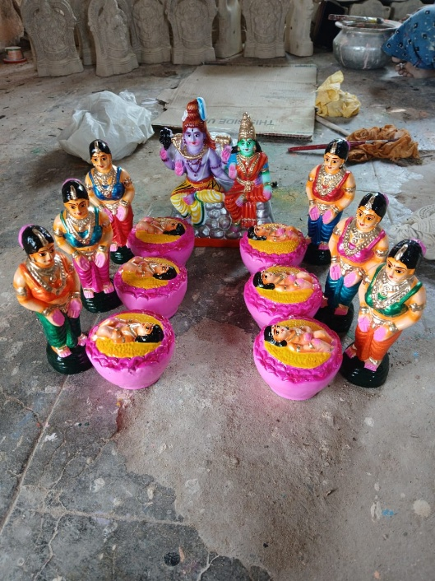 | KAARTHIGAI PENGAL SET  Divine Kaarthigai Pengal, reflecting the sacred story of the six maidens who lovingly raised Lord Murugan, radiating devotion and compassion | BV130 | 350 USD
131 | 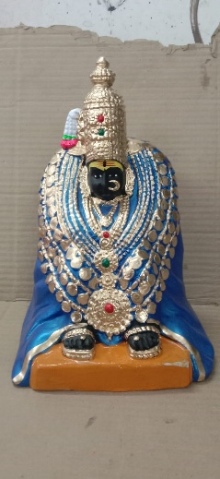 | AMMAN  A spiritually powerful Amman, invoking protection, prosperity, and the infinite grace of the Divine Mother | BV131 | Coming soon
132 | 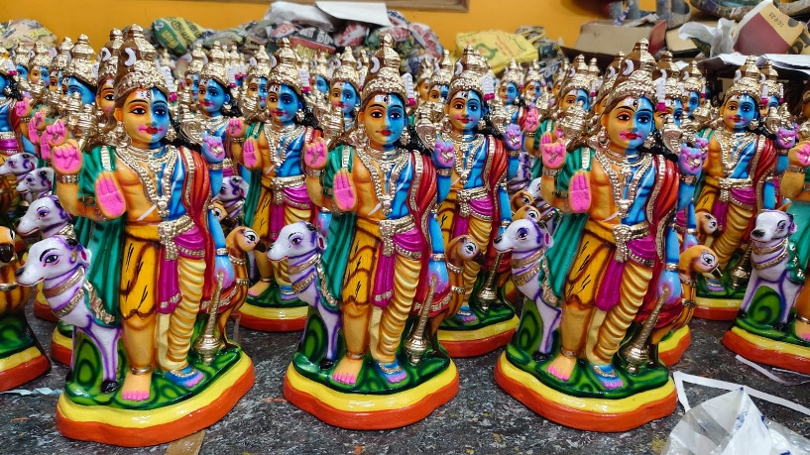 | AANDAVAR Single piece  Holy Aandavar, reflecting the serene and compassionate form of the Lord who safeguards all life | BV132 | 100 USD

 | EARTHENWARE GOLU DOLLS CATALOUGE SHYAM HANDYKRAFTS | 100% Exports Free Shipping
SR No. | IMAGE | NAME AND DESCRIPTION | CODE No. | RATE IN USD
133 | 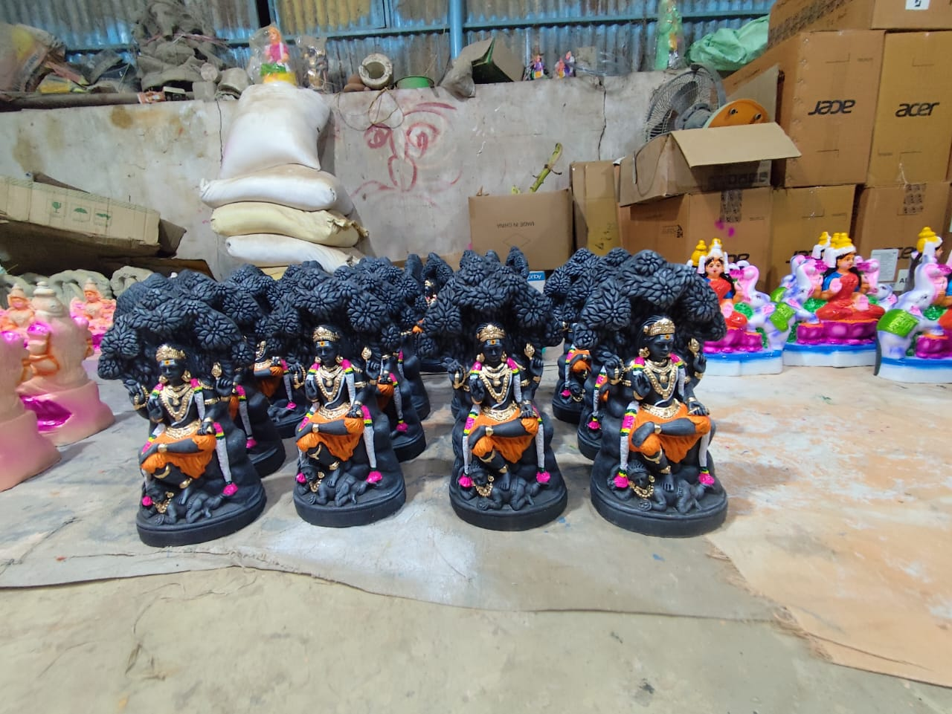 | Dhatchina Moorthy single piece  Holy Dhatchina Moorthy, reflecting the serene presence of the Guru who guides seekers towards self-realization | BV133 | 99 USD
134 | 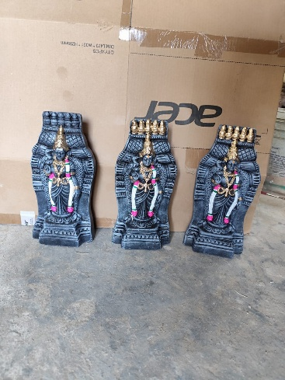 | Meenakchi Gopuram single piece  “A spiritually majestic Meenakshi Gopuram, invoking devotion, prosperity, and the eternal grace of Goddess Meenakshi.” | BV134 | 99 USD
135 | 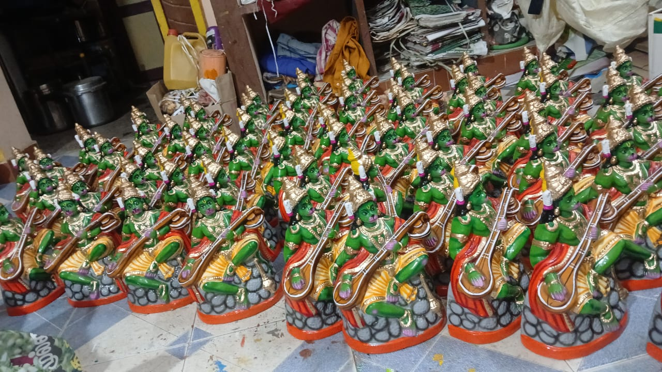 | VEENAI ANUMAN single piece  “Sacred Veenai Hanuman, depicting Lord Hanuman playing the veena, symbolizing devotion expressed through divine music and surrender.” | BV135 | 110 USD

 | EARTHENWARE GOLU DOLLS CATALOUGE SHYAM HANDYKRAFTS | 100% Exports Free Shipping
SR No. | IMAGE | NAME AND DESCRIPTION | CODE No. | RATE IN USD
136 | 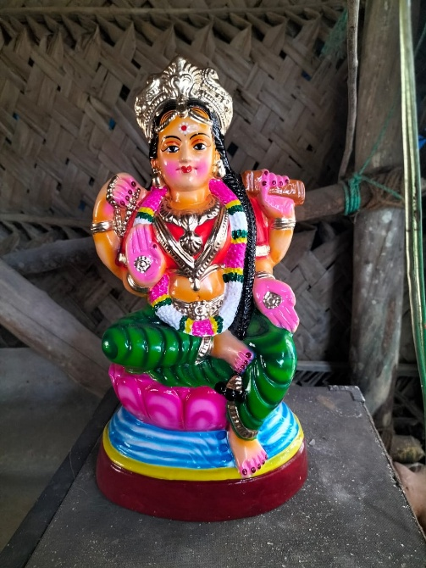 | Chaturbuj Amman  Divine Chaturbuj Amman, symbolizing the Goddess in her powerful four-armed form, blessing devotees with strength, prosperity, and wisdom. | BV136 | 100 USD
137 | 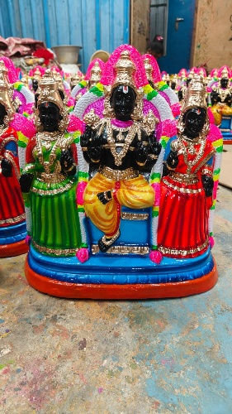 | Koodal Alagar Set  Blessed Koodal Alagar set, embodying the sacred presence of Perumal in His majestic form at the holy Koodal temple in Madurai. | BV137 | 150 USD
138 | 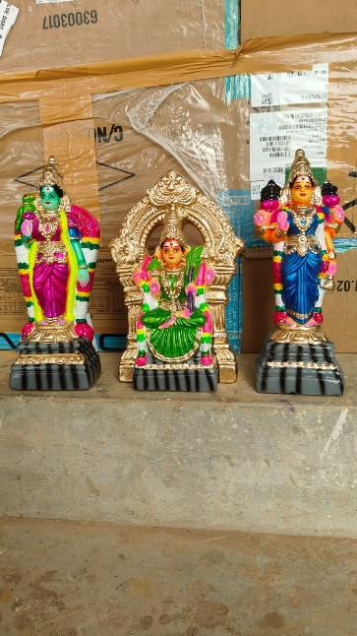 | AMMAN KOIL SET  Holy Amman Koil, reflecting the sacred darshan of the Goddess in her shrine, invoking devotion and spiritual fulfillment | BV138 | Coming soon

 | EARTHENWARE GOLU DOLLS CATALOUGE SHYAM HANDYKRAFTS | 100% Exports Free Shipping
SR No. | IMAGE | NAME AND DESCRIPTION | CODE No. | RATE IN USD
139 | 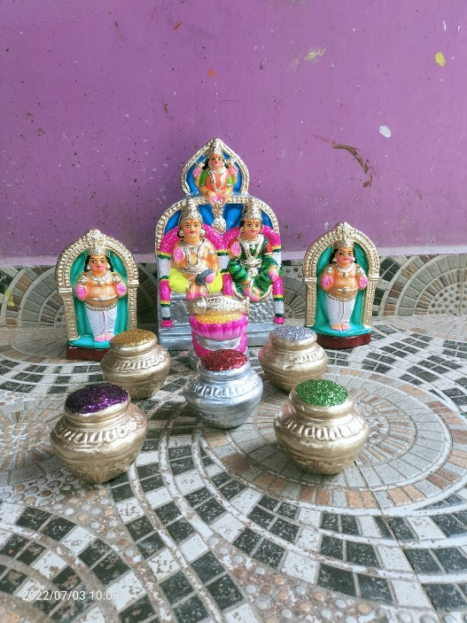 | KUBER AASIRWADAM SET  Divine Kuber Aasirwadam, symbolizing the celestial treasurer granting fortune, stability, and material well-being. | BV139 | 115 USD
140 | 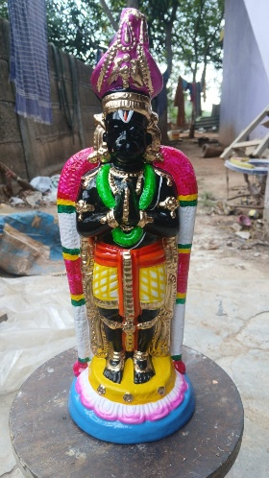 | NAMAKKAL ANJANEYAR  Divine Namakkal Anjaneyar, symbolizing absolute surrender and boundless devotion to Lord Rama | BV140 | 100 USD
141 | 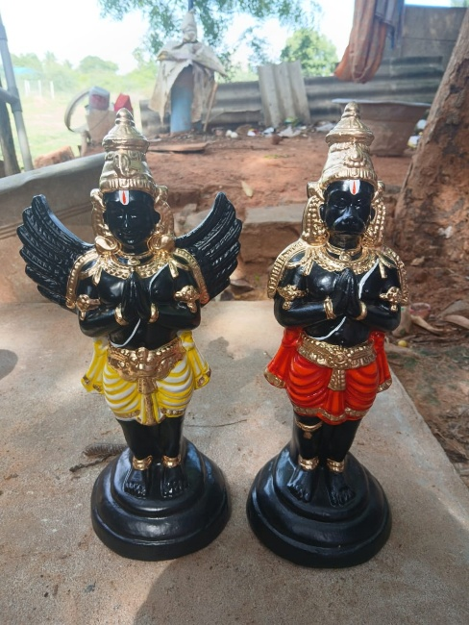 | KARUDAN ANGANEYAR SET  Divine Karudan Anganeyar, symbolizing the combined power of Garuda and Hanuman, safeguarding devotees with unwavering faith and courage | BV141 | 200 USD

 | EARTHENWARE GOLU DOLLS CATALOUGE SHYAM HANDYKRAFTS | 100% Exports Free Shipping
SR No. | IMAGE | NAME AND DESCRIPTION | CODE No. | RATE IN USD
142 | 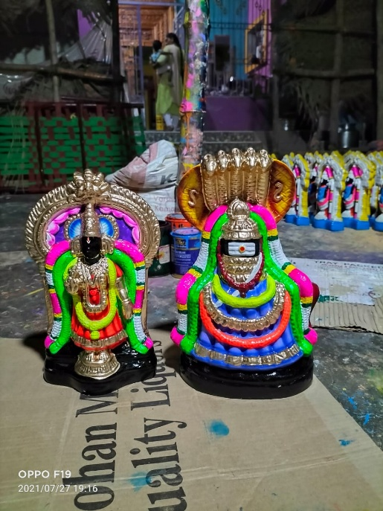 | ANNA MALAIYAAR SET  Sacred Annamalaiyar set, depicting Lord Shiva of Arunachala, radiating divine light, strength, and spiritual liberation | BV142 | 150 USD
143 | 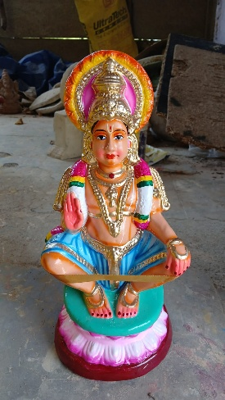 | AYYAPPAN  A spiritually powerful Ayyappan, invoking courage, discipline, and the sacred grace of ‘Swamiye Saranam Ayyappa’ | BV143 | 75 USD
144 | 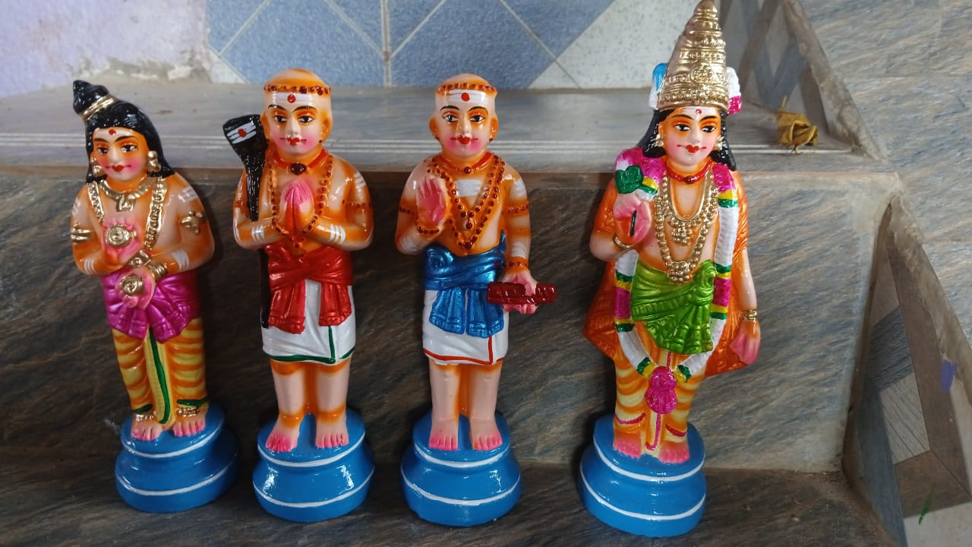 | NAALVAR SET  Blessed Naalvar set, embodying bhakti, humility, and the spiritual legacy of the four revered saints | BV144 | 85 USD

 | EARTHENWARE GOLU DOLLS CATALOUGE SHYAM HANDYKRAFTS | 100% Exports Free Shipping
SR No. | IMAGE | NAME AND DESCRIPTION | CODE No. | RATE IN USD
145 | 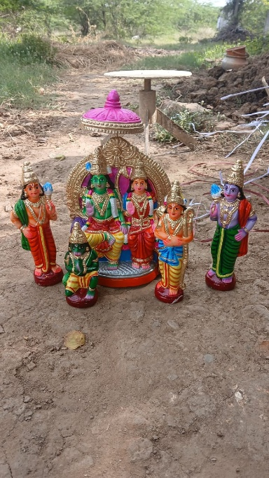 | RAMAR SET  Blessed Ramar set, embodying truth, loyalty, and the sacred bond of the Ramayana’s divine family | BV145 | 175 USD
146 | 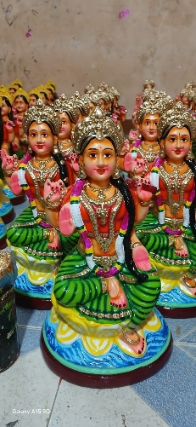 | AMMAAL  Holy Ammaal, reflecting the gentle and compassionate nature of the Goddess seated in divine poise | BV146 | Coming soon
147 | 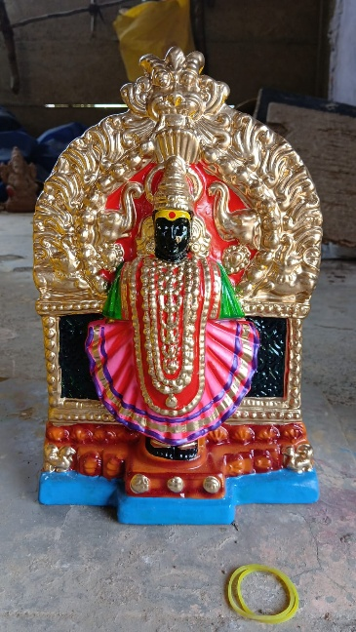 | DEVI  Blessed Devi, embodying beauty, power, and the nurturing presence of the Divine Mother in her majestic form.” | BV147 | Coming soon

 | EARTHENWARE GOLU DOLLS CATALOUGE SHYAM HANDYKRAFTS | 100% Exports Free Shipping
SR No. | IMAGE | NAME AND DESCRIPTION | CODE No. | RATE IN USD
148 | 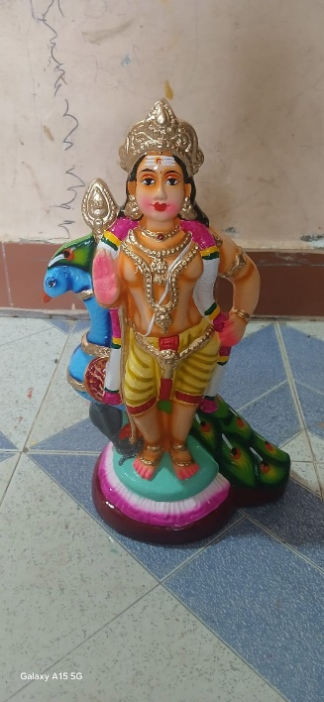 | MAYIL MURUGAR  Sacred Mayil Murugar, depicting Lord Murugan seated on the peacock, radiating valor, wisdom, and divine grace. | BV148 | 99 USD
149 | 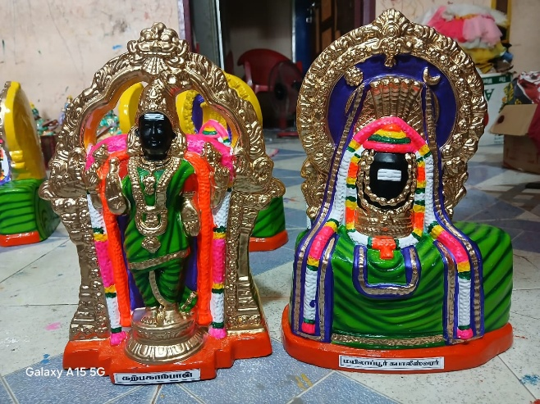 | ANNA MALAIYAAR SET  Holy Annamalaiyar, reflecting the divine light of Tiruvannamalai, granting peace, devotion, and spiritual upliftment | BV149 | 150 USD
150 | 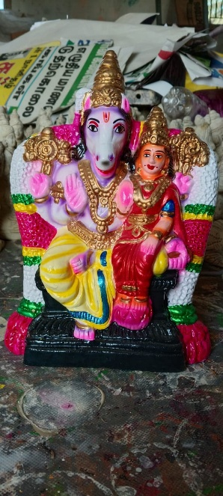 | LAXMI AYAGRIVAR  A spiritually powerful Lakshmi Hayagrivar, invoking education, prosperity, and the divine blessings of knowledge and fortune | BV150 | 75 USD

 | EARTHENWARE GOLU DOLLS CATALOUGE SHYAM HANDYKRAFTS | 100% Exports Free Shipping
SR No. | IMAGE | NAME AND DESCRIPTION | CODE No. | RATE IN USD
151 | 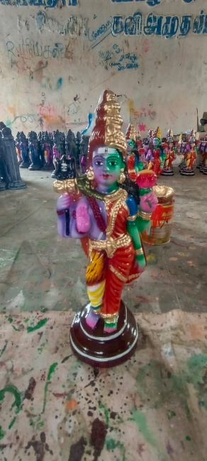 | ArthaNareeswarar  Sacred Artha Nareeswarar, the divine union of Shiva and Shakti, symbolizing perfect balance and cosmic harmony. | BV151 | 99 USD
152 | 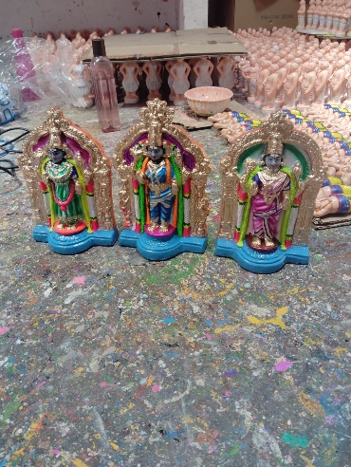 | AMMAN  Divine Amman trio, symbolizing the powerful presence of the Goddess blessing devotees with strength, peace, and abundance | BV152 | Coming soon
153 | 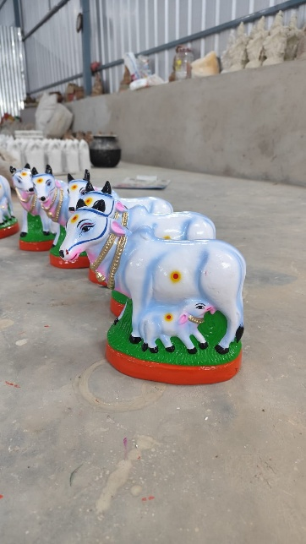 | Pasumaadu Kannukutti  Divine Pasumaadu Kaanukutti, representing Kamadhenu’s blessings of prosperity, care, and motherly love.” | BV153 | 99 USD

 | EARTHENWARE GOLU DOLLS CATALOUGE SHYAM HANDYKRAFTS | 100% Exports Free Shipping
SR No. | IMAGE | NAME AND DESCRIPTION | CODE No. | RATE IN USD
154 | 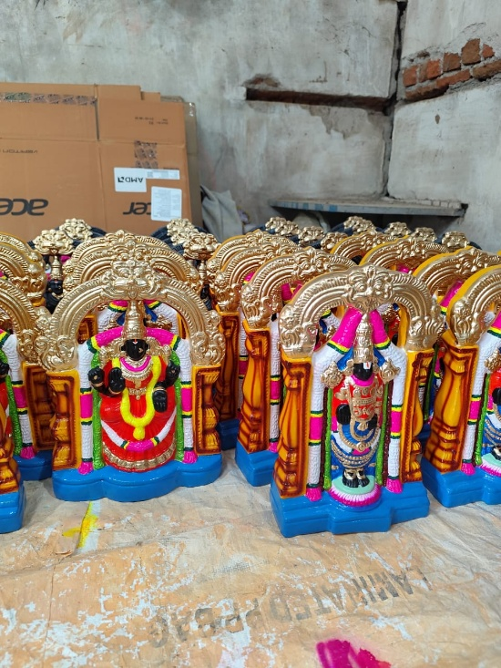 | Amman Perumal set  A spiritually auspicious Amman Perumal set, invoking prosperity, protection, and the combined blessings of the Divine Mother and Lord Vishnu | BV154 | Coming soon
155 | 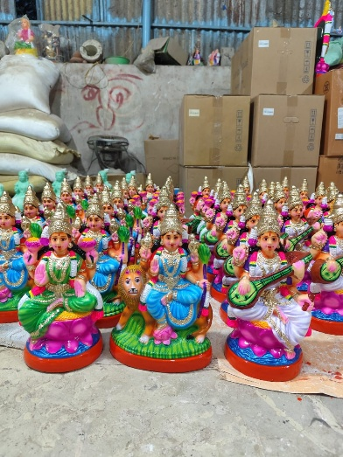 | LAXMI DURGA SARASWATI SET  “Blessed Lakshmi Durga Saraswati set, embodying the threefold grace of prosperity, protection, and learning | BV155 | 110 USD
156 | 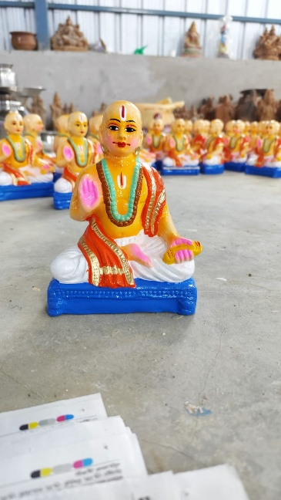 | RAMANUJAR  Sacred Ramanujar, the great Vaishnavite saint, radiating devotion, wisdom, and the path of surrender to Lord Vishnu. | BV156 | 99 USD

 | EARTHENWARE GOLU DOLLS CATALOUGE SHYAM HANDYKRAFTS | 100% Exports Free Shipping
SR No. | IMAGE | NAME AND DESCRIPTION | CODE No. | RATE IN USD
157 | 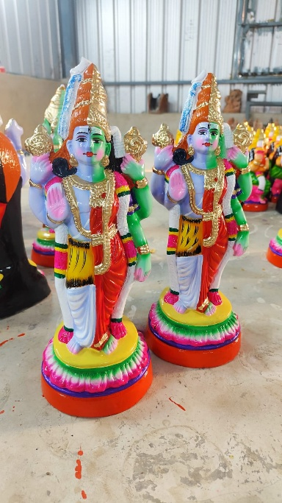 | Arthanareeswarar  Single piece  Sacred Arthanareeswarar, the divine fusion of Shiva and Shakti, symbolizing perfect balance and cosmic unity.” | BV157 | 99 USD
158 | 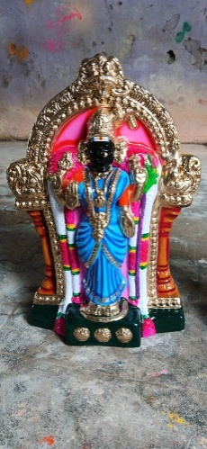 | AMMAN  Divine Amman, symbolizing the nurturing Shakti, blessing devotees with strength, peace, and abundance | BV158 | Coming soon
159 | 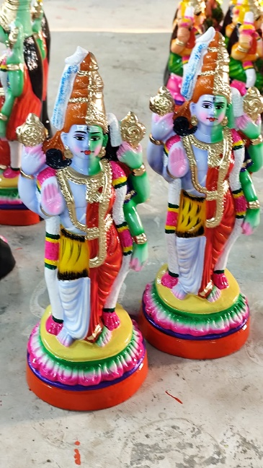 | Arthanareeswarar Single piece  Sacred Arthanareeswarar, the divine fusion of Shiva and Shakti, symbolizing perfect balance and cosmic unity.” | BV159 | 99 USD

 | EARTHENWARE GOLU DOLLS CATALOUGE SHYAM HANDYKRAFTS | 100% Exports Free Shipping
SR No. | IMAGE | NAME AND DESCRIPTION | CODE No. | RATE IN USD
160 | 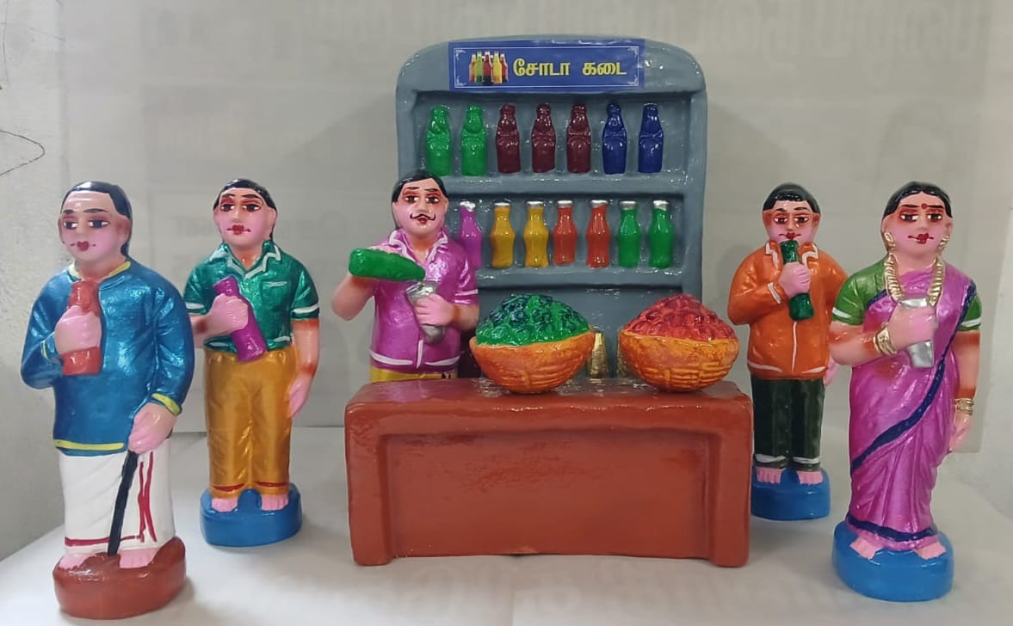 | SODA KADAI SET  Traditional Soda Kadai set, depicting a lively village refreshment stall, bringing nostalgic charm and everyday culture to life | BV160 | 300 USD
161 | 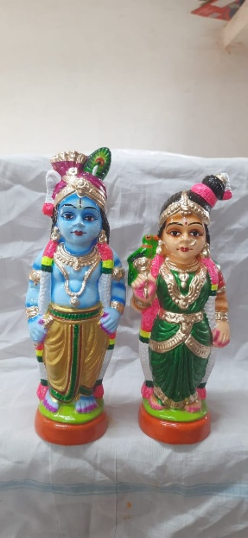 | AANDAL KRISHNAR SET  Blessed Andal Krishnar set, embodying devotion, beauty, and the soulful longing of Andal for Lord Krishna | BV161 | 75 USD
162 | 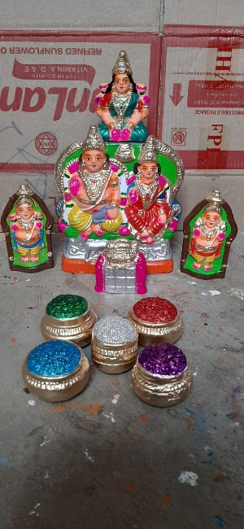 | KUBERAN SET  Sacred Kuberan set, depicting Lord Kubera, the divine treasurer, bestowing wealth, prosperity, and abundance.” | BV162 | 110 USD

 | EARTHENWARE GOLU DOLLS CATALOUGE SHYAM HANDYKRAFTS | 100% Exports Free Shipping
SR No. | IMAGE | NAME AND DESCRIPTION | CODE No. | RATE IN USD
163 | 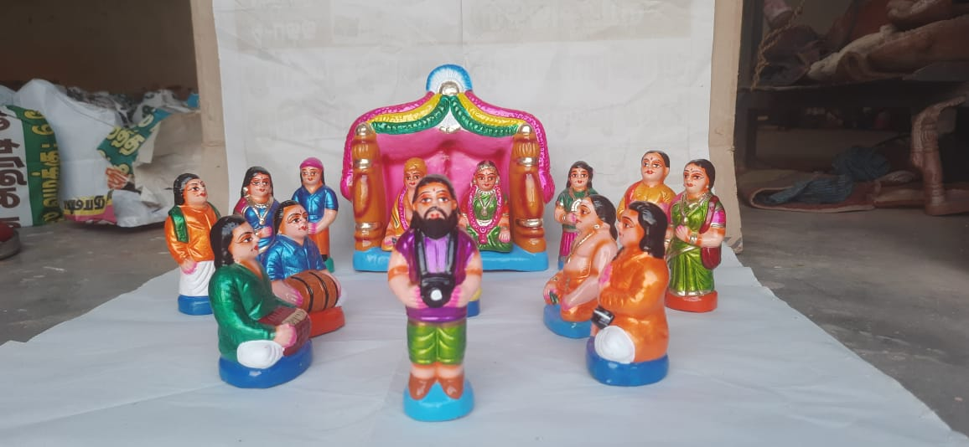 | WEDDING SET  Celebrate every sacred moment—our Wedding Set brings tradition to life | BV163 | 150 USD

 | EARTHENWARE GOLU DOLLS CATALOUGE SHYAM HANDYKRAFTS
SR No. | IMAGE | NAME AND DESCRIPTION | CODE No. | RATE IN USD

 | EARTHENWARE GOLU DOLLS CATALOUGE SHYAM HANDYKRAFTS
SR No. | IMAGE | NAME AND DESCRIPTION | CODE No. | RATE IN USD

 | EARTHENWARE GOLU DOLLS CATALOUGE SHYAM HANDYKRAFTS
SR No. | IMAGE | NAME AND DESCRIPTION | CODE No. | RATE IN USD

 | EARTHENWARE GOLU DOLLS CATALOUGE SHYAM HANDYKRAFTS
SR No. | IMAGE | NAME AND DESCRIPTION | CODE No. | RATE IN USD

 | EARTHENWARE GOLU DOLLS CATALOUGE SHYAM HANDYKRAFTS
SR No. | IMAGE | NAME AND DESCRIPTION | CODE No. | RATE IN USD

